

American International University-Bangladesh (AIUB)
Department of Computer Science Faculty of Scienc&Technology(FST)
BOOK SHOP MANAGEMENT SYSTEM
A Software Engineering Project Submitted
By Group 2

Semester-->Fall_25-26 |  | Section:Y
SL | Student Name | Student ID
1 | Nujhat Tasnim | 23-53077-3
2 | Fatema Abdden Nedhi | 23-54451-3
3 | Jeba Tasnim Khan | 23-54856-3
4 | Sakib Monir Hossen | 24-58473-2
5 | Chowa Roy | 23-52716-3

Table of Contents

1. Project Proposal .................................................................... 3
1.1 Background to the Problem ......................................... 3
1.2 Selection of Process Model ........................................... 4
2. Software Requirement Specification (SRS) / PRD .............6
2.1 Scopes and Features ..................................................... 6
2.2 User Story Table ........................................................... 8
2.3 Requirements Traceability Matrix ............................. 9
2.3.1 Functional Requirements ......................................... 9
2.3.2 Non-Functional Requirements ................................ 10
3.Software Design .....................................................................12
3.1 System Design .............................................................. 12
3.2 UI Design using Figma ............................................….15
4.Git Workflow ........................................................................ 17
5.Software Testing ................................................................... 31
6.Conclusion ............................................................................. 44

1.PROJECT PROPOSAL

1.1 Background to the Problem
Many small bookshops still use old methods to run their business. They use pen and paper or Excel files to manage books, track sales, and check stock. These old methods create many problems for shop owners and workers.

Problems with Managing Books and Stock
When new books arrive, workers write down all details by hand. This takes time and mistakes happen. Papers get lost or handwriting is hard to read. Finding a specific book becomes difficult.
Stock management is another big problem. When a book is sold, workers often forget to update stock records. The records may show 5 books in stock, but only 2 are on the shelf. When a customer asks for that book, the worker says yes but cannot find it. This makes customers unhappy and the shop loses sales.

Problems with Sales and Money
Recording sales manually is slow. Workers may write wrong prices or make calculation errors. At the end of the day, the owner has to add up all sales by hand. This takes hours and mistakes are common. The owner also cannot see which books sell well. Without this information, it is hard to know what books to order more of.

Problems with Security
Manual systems have no proper security. Anyone can open the notebook or Excel file. There is no login system to control access.
Employees can see private information like profits. They can change prices or delete sales without permission. The owner never knows who made these changes.
There is no backup. If a file is lost, all data is gone forever. Former employees may have copied files before leaving. The owner cannot stop this.
When multiple people use the same file, data gets overwritten and becomes wrong. There is no record of who did what.
These security problems put the business at great risk.

Problems with Managing Employees
Training new workers is difficult because they must learn the manual system. There is no proper training guide. Different workers do things in different ways. Some write in one notebook, others use another. This creates confusion and mistakes.
When workers leave, there is no way to remove their access. They may have copies of Excel files or photos of records. The owner has no control over former employees accessing business data. This is a security risk.

Target Users of This System:
This Book Shop Management System is built to solve all these problems. It is a simple computer program that helps bookshops run smoothly. The system has four types of users.
1. Admin (Shop Owner or Manager)
- Log in securely.
- Add and delete employees.
- Add, update, and delete books.
- Add and manage suppliers.
- View all sales and reports.
- View customers and suppliers list.
2. Employee (Sales Person)
- Log in with their own account.
- Sell books by adding them to a cart.
- System auto-calculates total price.
- System auto-updates stock after sale.
- Check book stock and prices.
- Register new customers.
- View their own sales history.
3. Customer (Book Shop Member)
- Register with name, phone, and email.
- Log in and browse books.
- Search books by title or author.
- See price and stock availability.
- View their own purchase history.

4. Supplier
- Log in with their own account.
- View books they have supplied.
- See current stock of their books.
- Get low stock alerts.
- Update book prices and details.
- Cannot see customer or sales data.
By giving clear roles to Admin, Employee, Customer, and Supplier, this system makes bookshop work easier, faster, and safer. It helps owners run their business better, helps workers do their jobs without mistakes, helps customers find books easily, and helps suppliers manage their books efficiently.

  - Selection of Process Model :
For the BOOK SHOP MANAGEMENT SYSTEM , the SCRUM process model was chosen because it allows the system to be developed step by step. The project consists of several features such as product management, inventory control, sales handling, and reporting, which can be developed and tested in small parts.
In SCRUM, the work is divided into short development cycles called sprints. In each sprint, a set of features is selected from the backlog, developed, and tested. After every sprint, the team reviews the progress and makes improvements if needed.
SCRUM was selected because it supports team collaboration, regular feedback, and flexibility. It helped the team manage tasks efficiently using tools like Trello and allowed continuous improvement throughout the development process.
1. The project has multiple independent modules that can be developed in phases
2. Requirements can be refined during development
3. Continuous testing is possible after each sprint
4. Team collaboration and task tracking are easier using tools like Trello
5. Working software is delivered at the end of each sprint

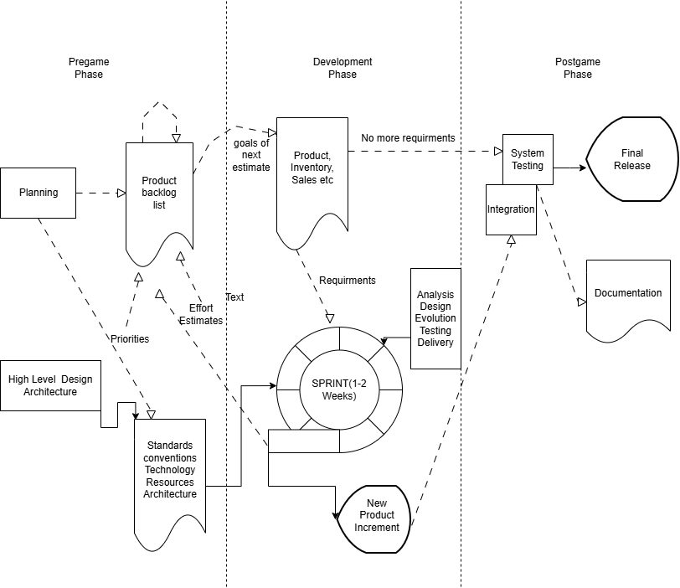
1.2 SCRUM diagram :

2. Software requirements specifications (SRS) / Product requirements documentations (PRD) :
2.1 Scopes and features :
A desktop-based Book Shop Management System for small to medium bookshops to replace manual records.
- Works offline
- Four user roles: Admin, Employee, Customer, Supplier
- Covers:
  - Book management
  - Sales & cart
  - Stock & low-stock alerts
  - User & profile management
  - Reports & sales history
  - Supplier book updates

Key Features :
Admin
- Secure login
- Add/update/delete books
- Add/delete employees
- View all sales & reports (profit, best-selling books)
- View customer & supplier lists
- Add suppliers
- Change password & logout
Employee
- Secure login
- Search books, view details
- Add to cart, complete sale (auto stock update)
- Register new customers
- View personal sales history
- Change password & logout

Customer
- Register & login
- Browse & search books (title/author)
- View purchase history
- Update profile & change password
- Logout
Supplier
- Login
- View supplied books & stock levels
- Receive low-stock alerts
- Update book prices/details
- View & edit profile, change password
- Logout

2.2 User Story Table
As A/An | I want to | So that | Acceptance Criteria
Admin | Login with username and password | I can access the system securely | Login page loads, valid credentials grant access, invalid shows error
 | Add new employees | I can give new workers access to the system | Employee details form works, new employee appears in users list
 | Delete employees | Former workers cannot access the system | Select employee, click delete, confirmation popup, employee removed from list
 | Add new books | Customers can see new books in the shop | Book form accepts all details, new book appears in product list
 | Update book details | Customers see correct information | Select book, change details, save, updated info shows in list
 | Delete books | Old books do not appear in search | Select book, confirm delete, book removed from list
 | View all sales | I can track business performance | Sales table loads with all transactions, sort by date
 | View sales reports | I can see total profit and best selling books | Reports show total sales, profits, and charts
 | Add new suppliers | I can keep track of who supplies books | Supplier form works, new supplier appears in list
 | View customer list | I can see all registered customers | Customer table loads with names, phone, email
 | Change my password | My account stays secure | Old password required, new password twice, success message
 | Logout | My account remains safe after use | Logout button works, redirect to login page
Employee | Login with my username and password | I can securely access the system and start my work | After successful login, the employee dashboard opens
 | Search for a book | I can quickly find a book requested by a customer | System shows list of matching books
 | View book details | I can see price, author, and stock | Selected book details appear clearly
 | Add books to cart | I can prepare the customer purchase easily | Selected books appear in cart list
 | Register new customers | Customers can become members | Customer form accepts details, new customer saved
 | Generate a bill | The total price is calculated automatically | System shows total amount and receipt
 | Complete a sale | The transaction is recorded properly | Stock updates automatically after sale
 | Check book stock | I can tell customers if a book is available | System displays current stock quantity
 | View my sales history | I can track the sales I completed | System shows list of past sales
Supplier | Login with my username and password | The system can authenticate me and I can trust it | After successful login, the data associated with the supplier should be accessible
 | View my own profile details | I can see the information I provided during registration | Information list table window including edit profile button
 | Update my information | I can correct or update my profile details | Information list table window including edit profile button
 | Change my password | My account can be more secure | Supplier must input old password and new password twice and receive success notification
 | View supplied books list | I can see all books I have supplied to the shop | Book list shows only my supplied books
 | Check stock levels of my books | I know when to offer more | Stock quantity displays for each of my books
 | Get low stock alerts | I can offer new stock before shop runs out | Alert shows when stock is below minimum
 | Update book prices | Shop has correct pricing | Change price, save, updated in system
 | Update book details | Shop has correct book information | Edit book details, save changes
 | Logout | My account remains safe after use | Logout button works
Customer | Register as a member | I can create my own account | Registration form with name, phone, email, password
 | Login with username and password | I can access my customer dashboard | Login page loads, valid credentials grant access
 | Browse books | I can see what books are available | Book list displays with title, author, price
 | Search for books by title | I can find specific books quickly | Search box works, shows matching books
 | Search for books by author | I can find books from my favorite author | Search by author shows correct results
 | View book details | I can see price and stock | Click book, shows full details and availability
 | View my purchase history | I can remember what I bought | Purchase list loads with date, book, price
 | Update my profile | My information stays correct | Edit profile, save changes
 | Change my password | My account stays secure | Old password required, new password twice
 | Logout | My account remains | Logout button works

2.3 Requirements Traceability Matrix
2.3.1 Functional Requirements :
System shall allow admin to login with username/email and password
System shall validate login credentials and show error if invalid
System shall redirect to role-based dashboard after successful login
System shall allow admin to add new employees
System shall allow admin to delete employees
System shall allow admin to add new books
System shall allow admin to update book details
System shall allow admin to delete books
System shall allow admin to view all sales records
System shall allow admin to view sales reports (total sales, profit, best-selling books)
System shall allow admin to view customer list
System shall allow admin to view supplier list
System shall allow admin to add new suppliers
System shall allow admin to change password
System shall allow admin to logout
System shall allow employee to login
System shall allow employee to search books
System shall allow employee to view book details
System shall allow employee to add books to cart
System shall allow employee to register new customers
System shall allow employee to complete sale (auto-calculate total, update stock)
System shall allow employee to view own sales history
System shall allow customer to register
System shall allow customer to login
System shall allow customer to browse books
System shall allow customer to search books by title
System shall allow customer to view purchase history
System shall allow customer to update profile
System shall allow customer to change password
System shall allow supplier to login
System shall allow supplier to view supplied books
System shall allow supplier to check stock levels
System shall allow supplier to receive low-stock alerts
System shall allow supplier to update book prices/details
System shall allow supplier to view/edit profile
System shall allow supplier to change password
2.3.2 Non-Functional Requirements :
Usability: System shall be easy to use for all roles
UI: Simple and clear graphical interface
Performance: Pages and data shall load within reasonable time
Reliability: System shall not crash during normal use
Availability: System shall be available when needed
Security: Only authorized users can access the system
Data security: Stored data shall be protected from unauthorized access
Data accuracy: System shall store and display correct data
Maintainability: System shall be easy to update
Scalability: System shall handle increasing records efficiently
Responsiveness: Buttons and actions respond quickly
Error handling: Meaningful error messages shall be shown
Compatibility: Works on supported OS
Backup: System shall support data backup
Consistency: Same design and behavior across all modules

3. SOFTWARE DESIGN (use, class, activity)
3.1 System Design :
a) Class diagram :
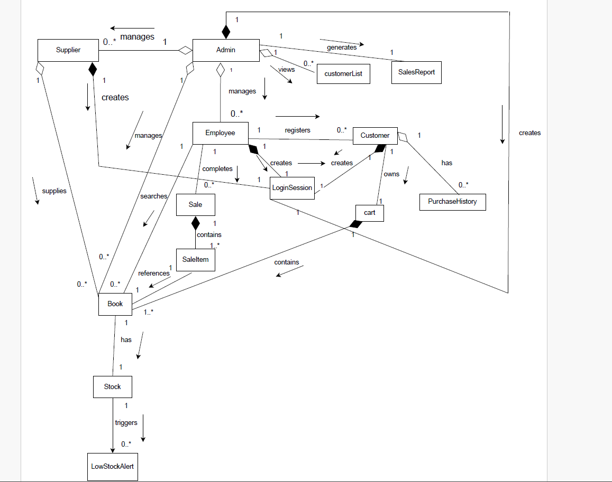

b) Use case diagram :

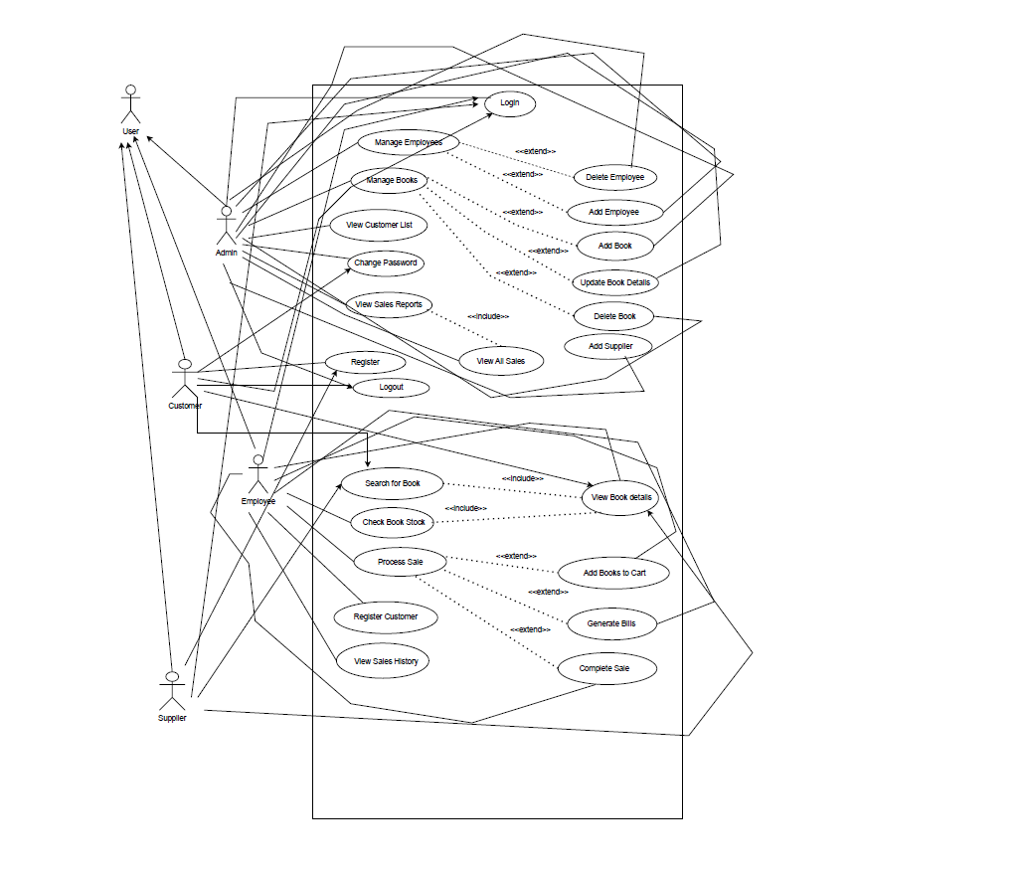

c) Activity diagram :

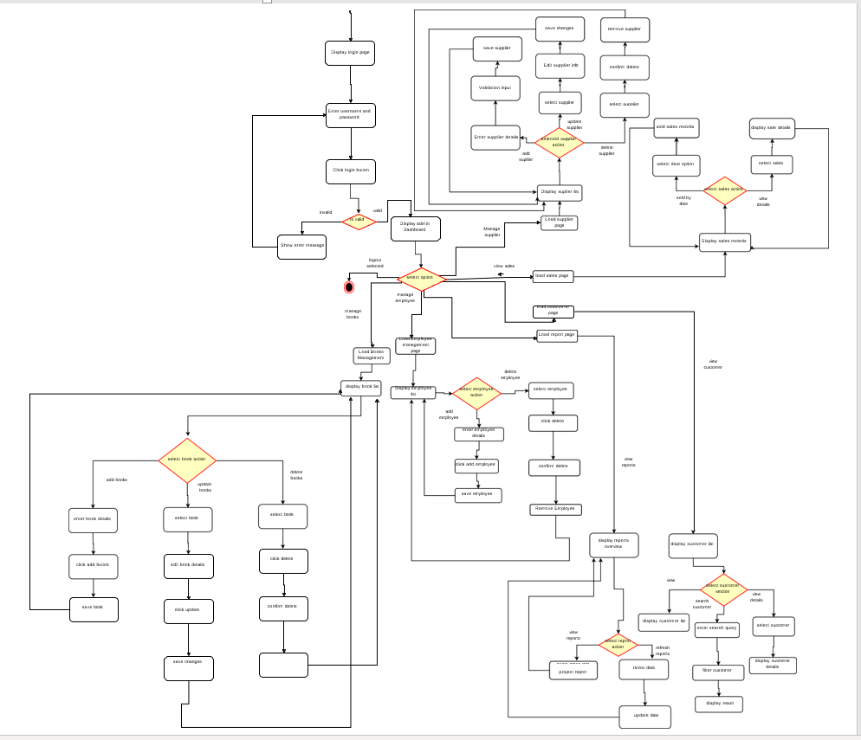

3.2UI / Wireframe Design using Figma:
a) Trello board screenshot :
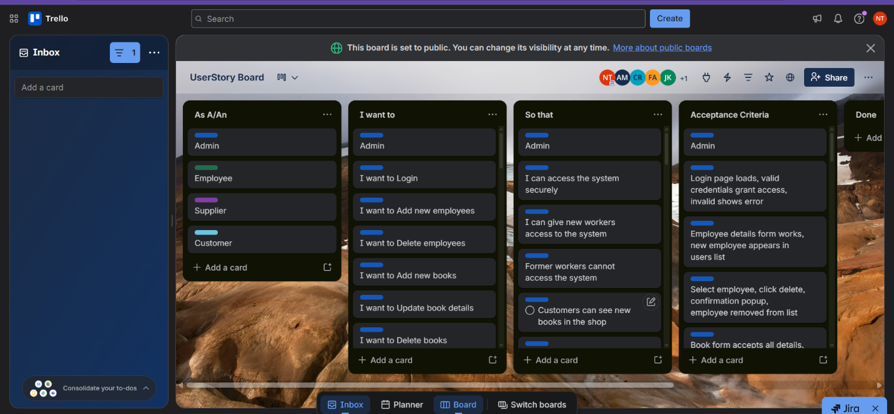b) UI / wireframes design individual :
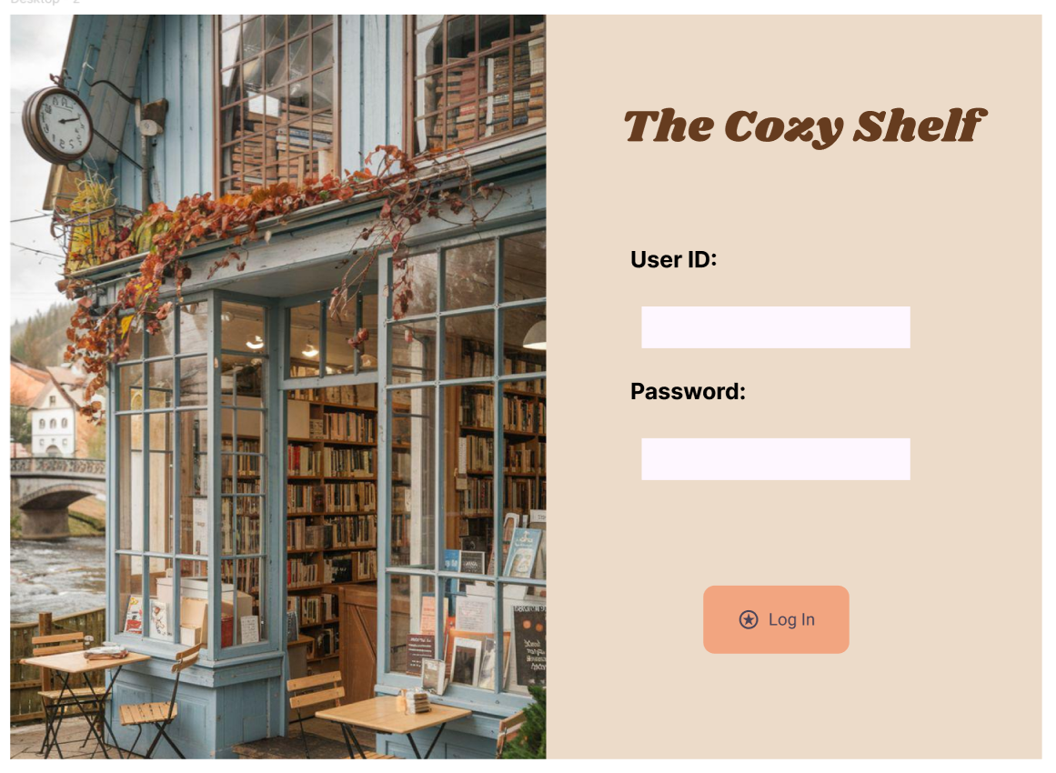
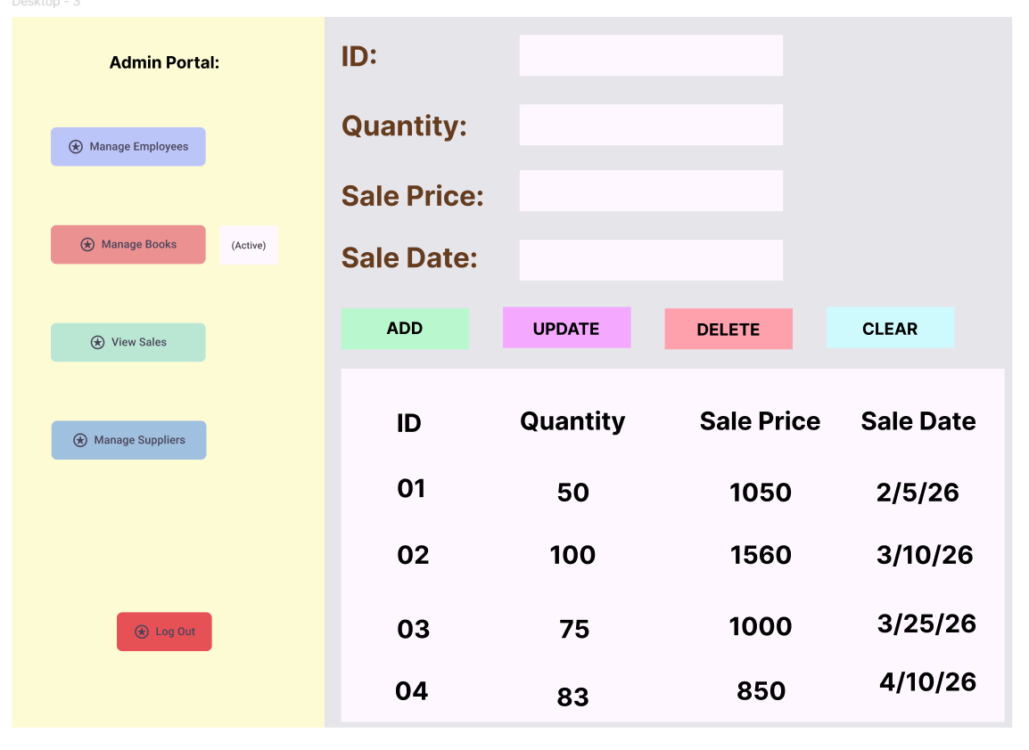
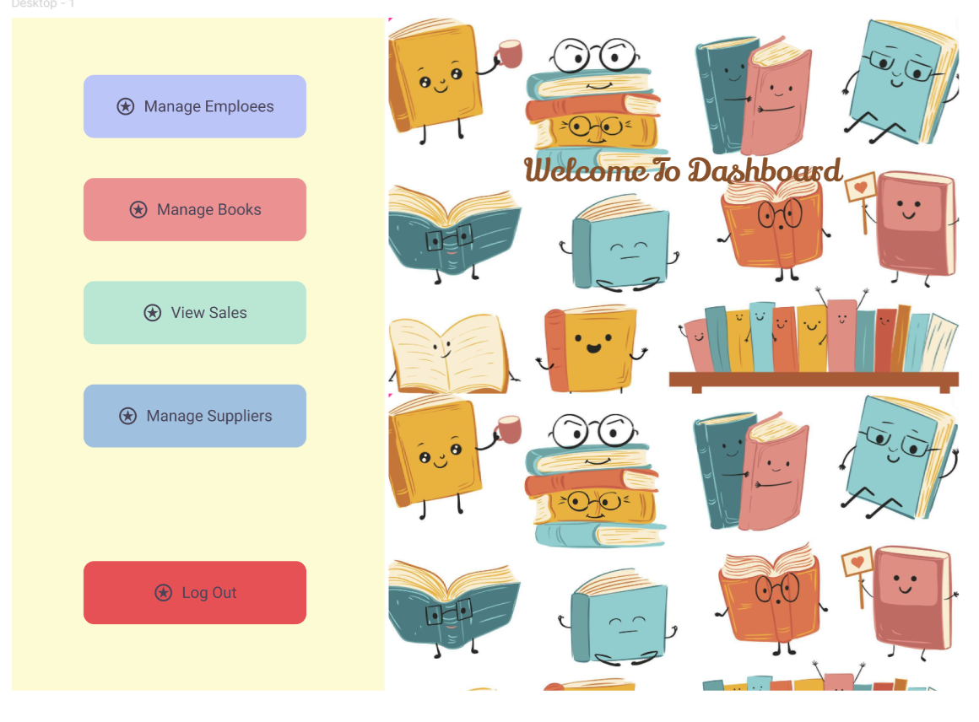

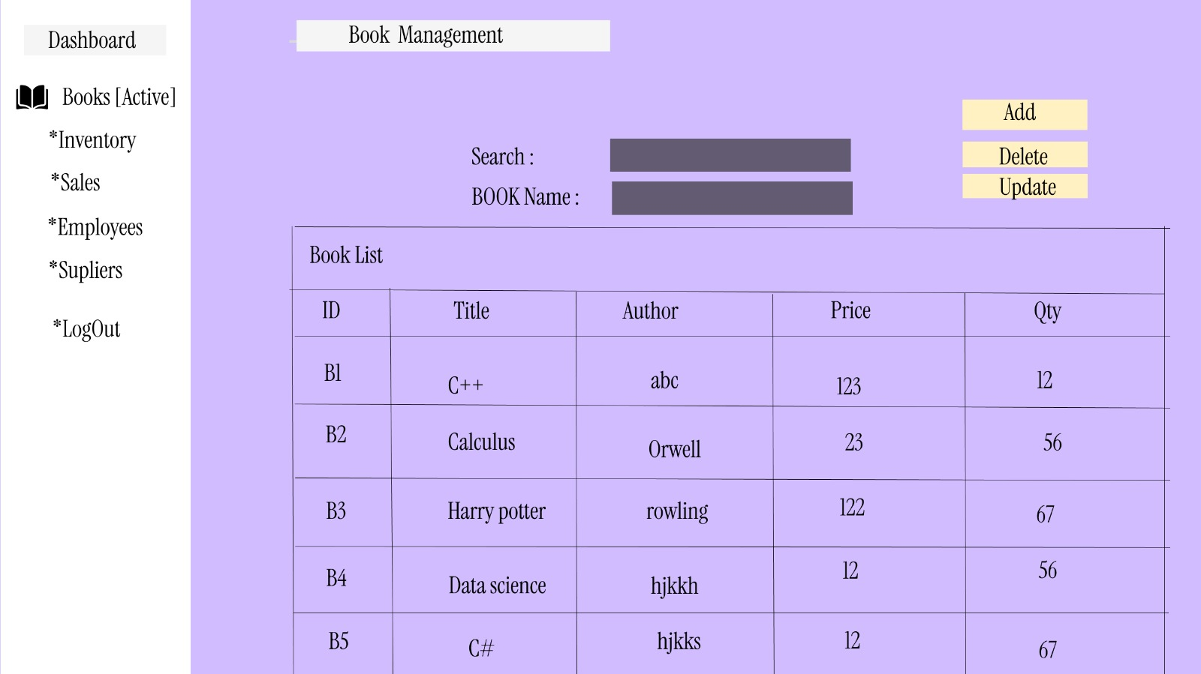
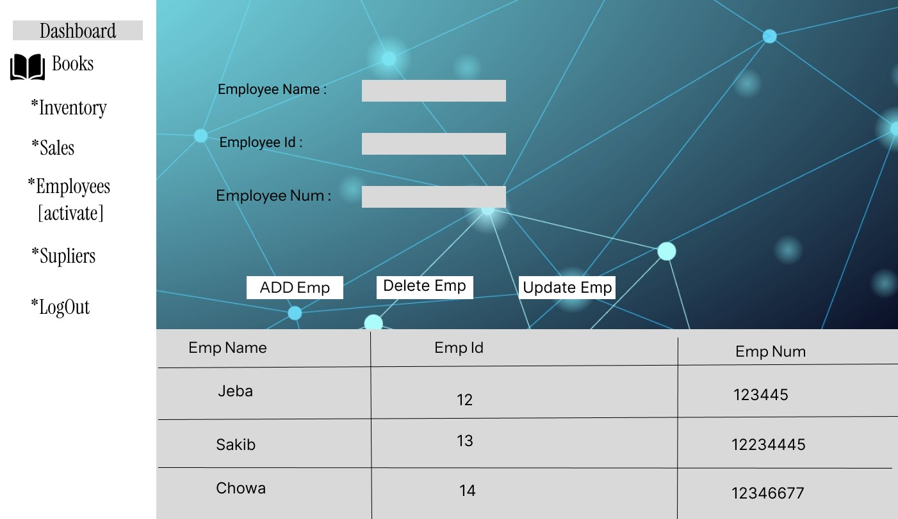

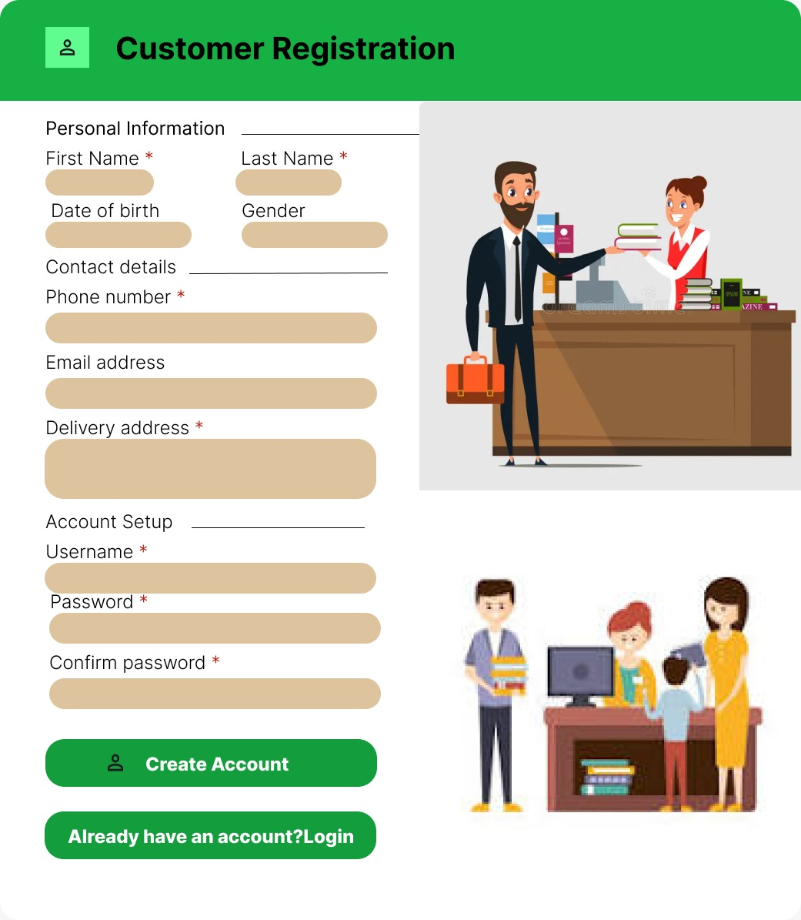

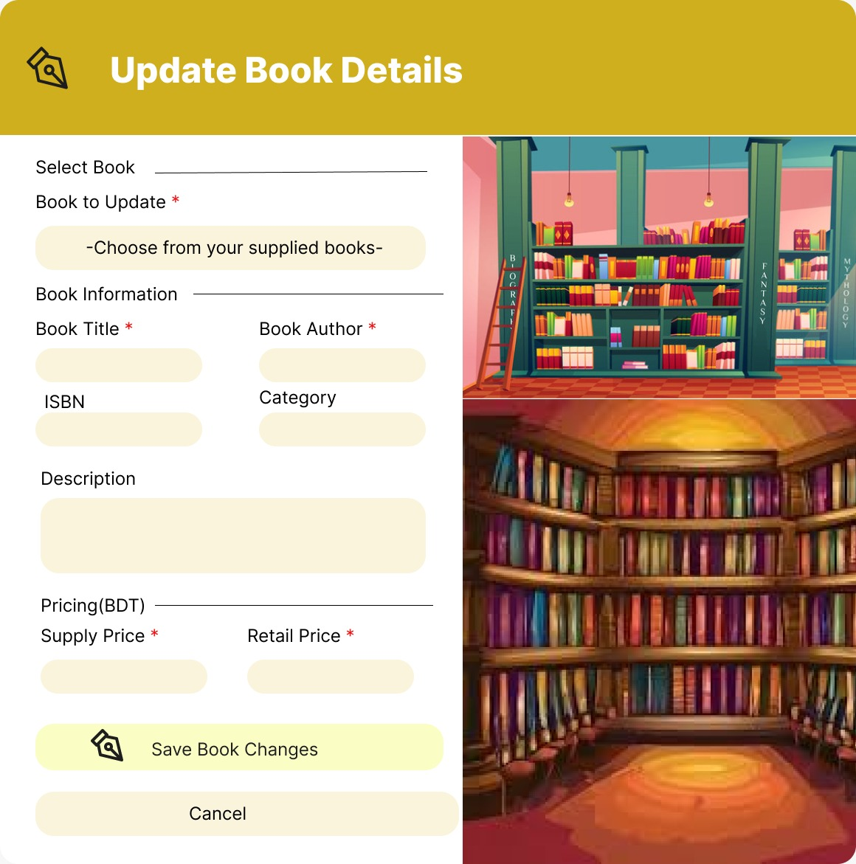

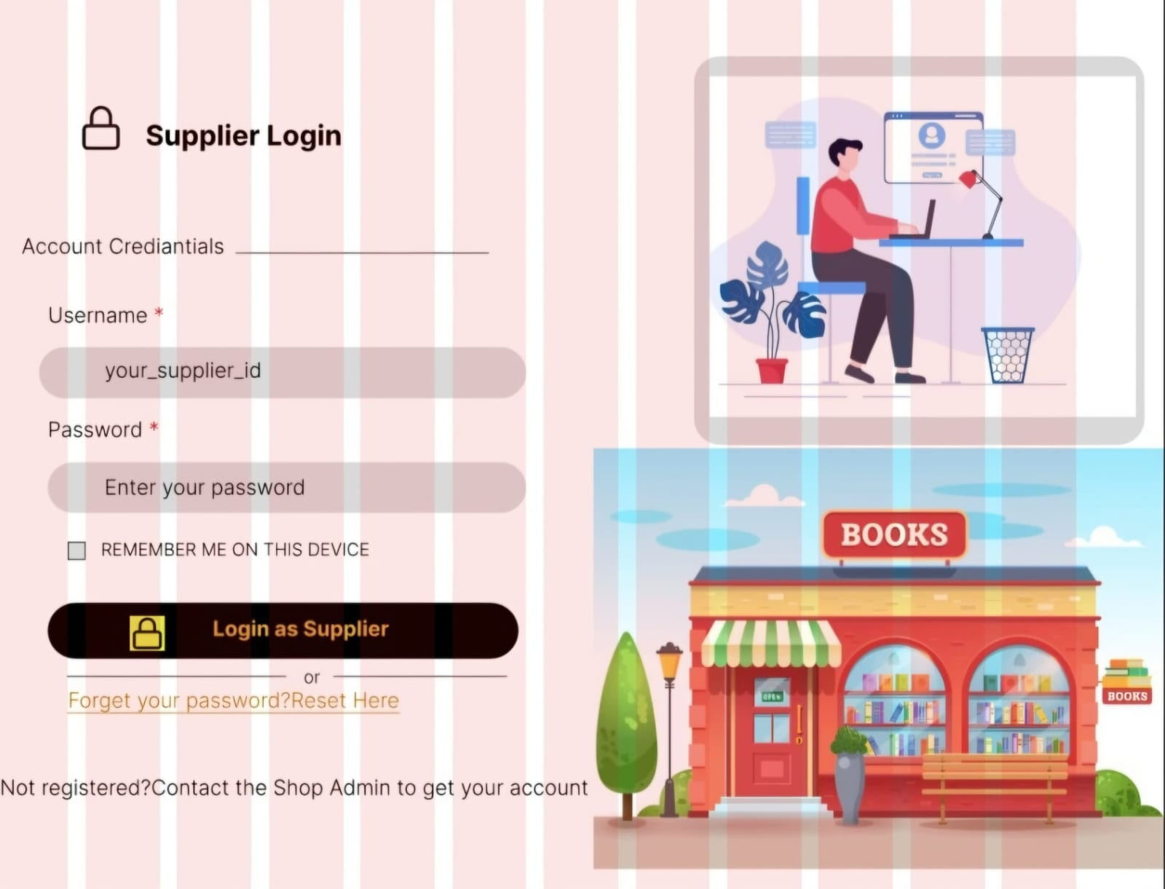


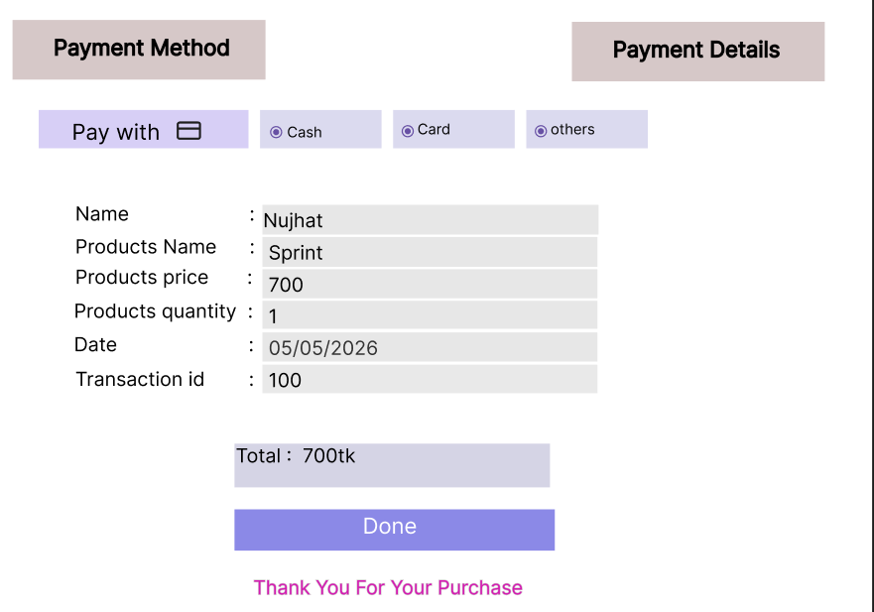
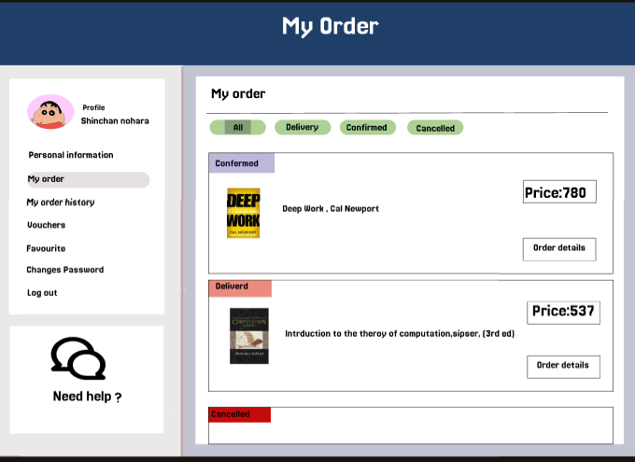

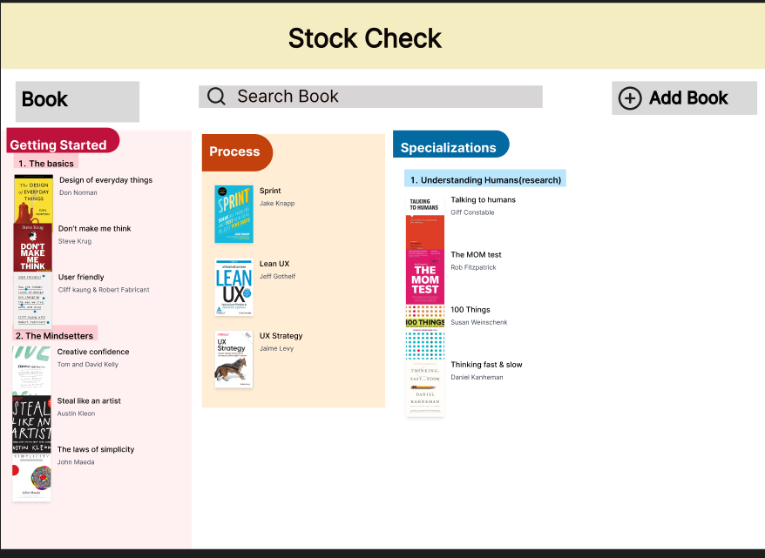
Trello board link :
https://trello.com/invite/b/69c21b184527afd6493adc31/ATTI9c978ee354e4a8923fcaa4a567fb48ac8FA3A1B2/userstory-board
Figma file link :
https://www.figma.com/design/8OleQZLR3dbHvCc3GRW9tl/Untitled?node-id=0-1&t=uhrA5W1r429qQIIG-1
https://www.figma.com/design/8DU7d9O8HsfN8gAq7ABEDE/Untitled?node-id=0-1&t=Xpamgsvm5DxEnx5c-1
https://www.figma.com/design/iAmn2Sm8XyIuwZGCRdv2zS/Untitled?node-id=0-1&t=FPLVPrlypweXLMMN-1
https://www.figma.com/design/XL99DczTSBAhA8u6wiMx65/Untitled?node-id=0-1&t=jBSX0qVv1MlbT57S-1
https://www.figma.com/design/9BfwR6bWmosZTvehiaynJr?node-id=

4. GIT WORKFLOW :
a) Screenshots of commit histories in all branches
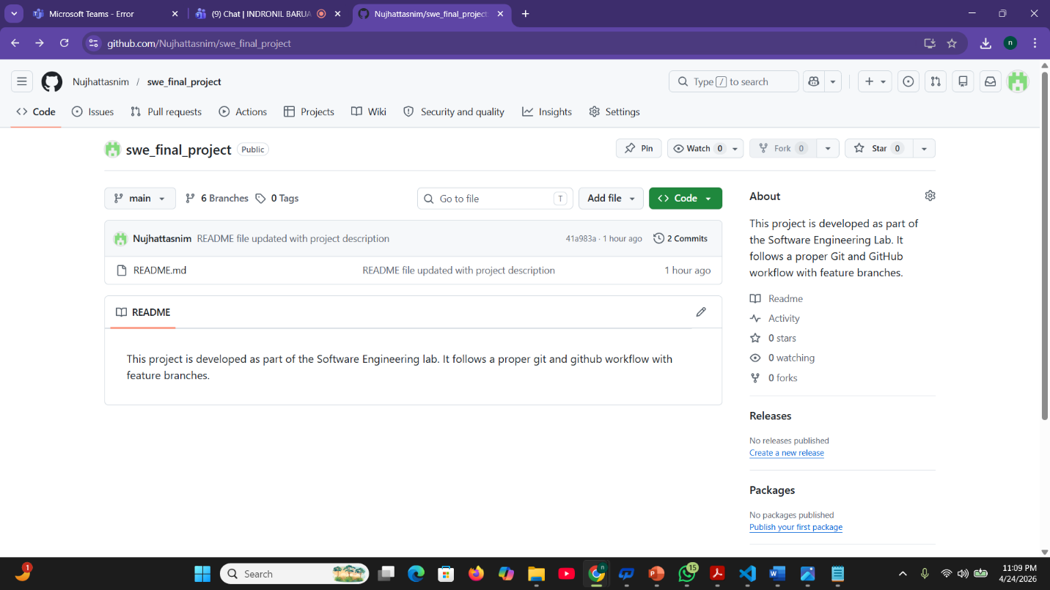
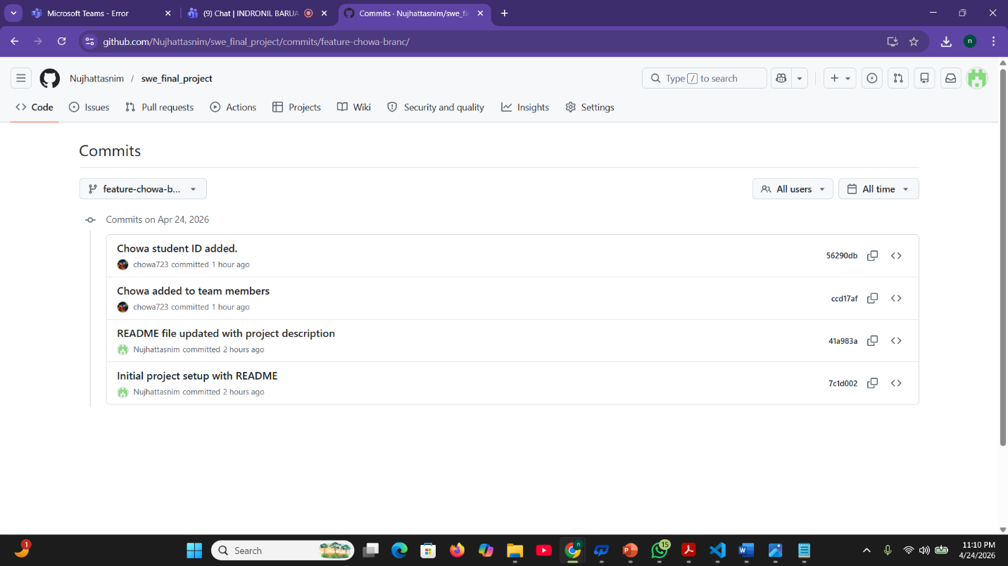

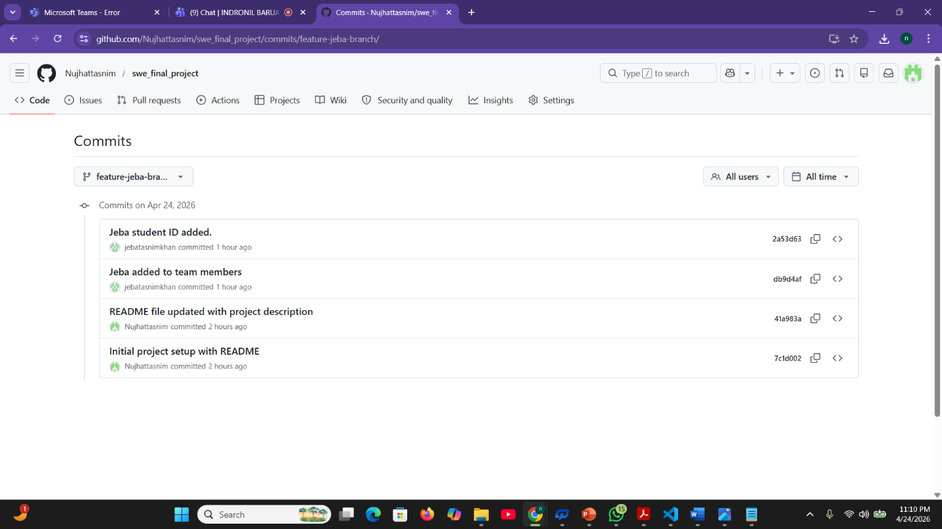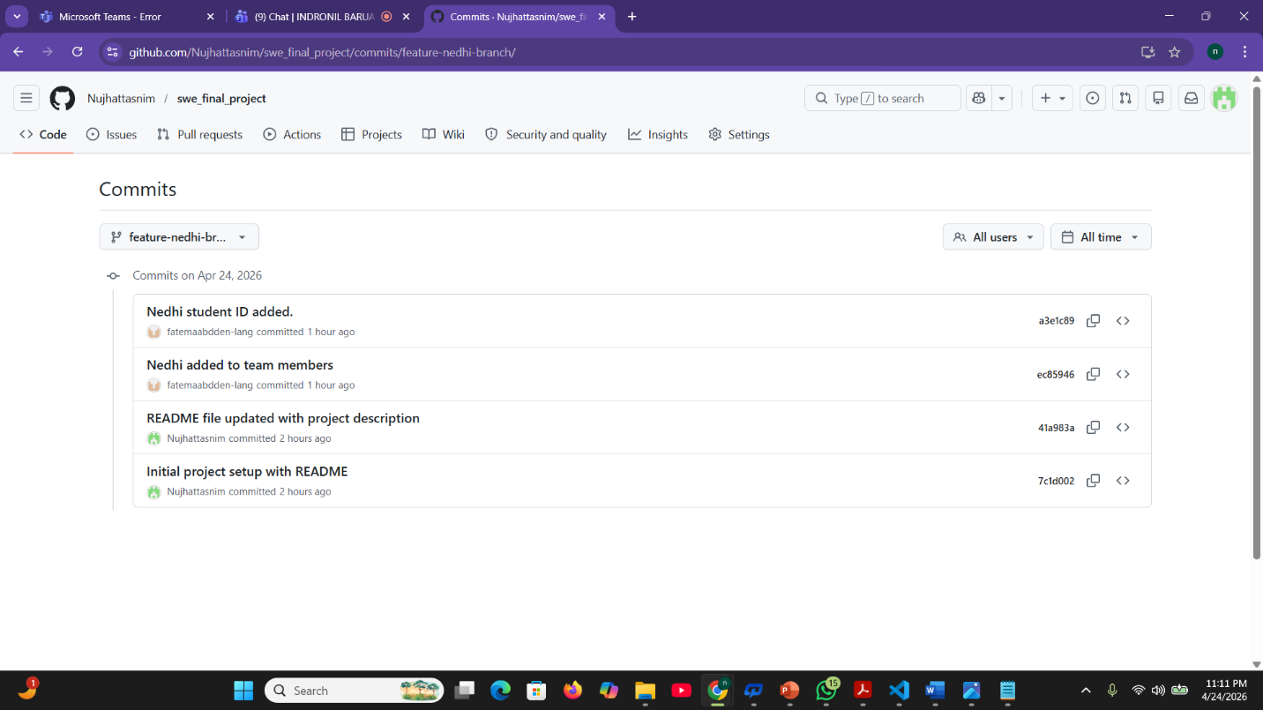

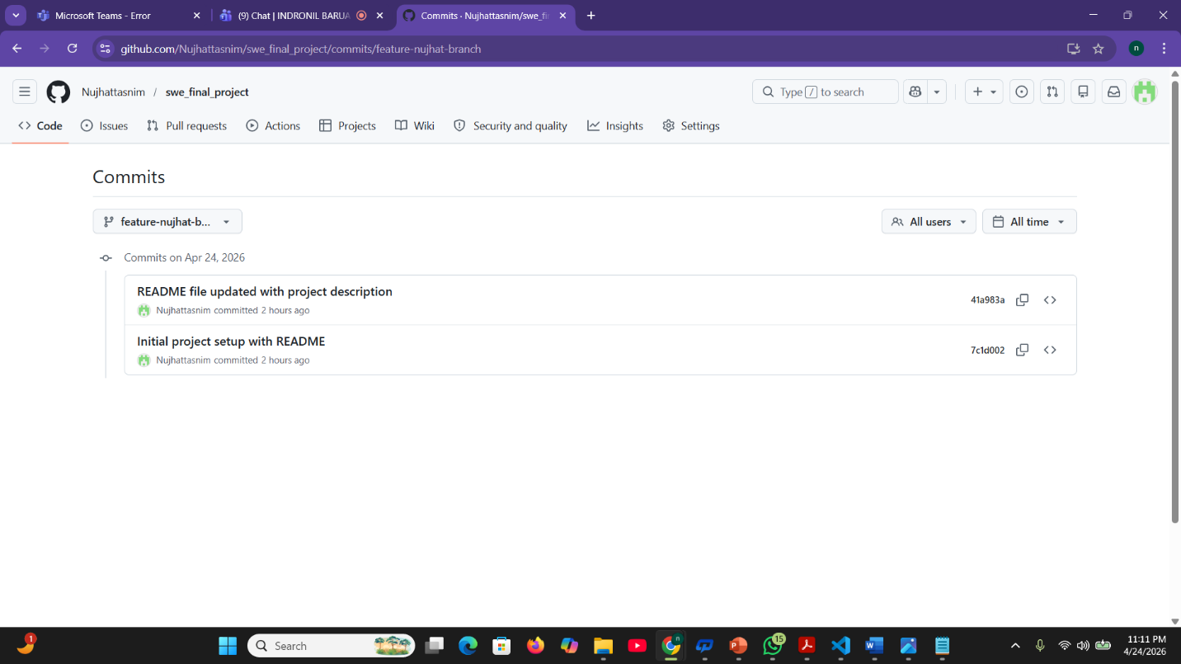
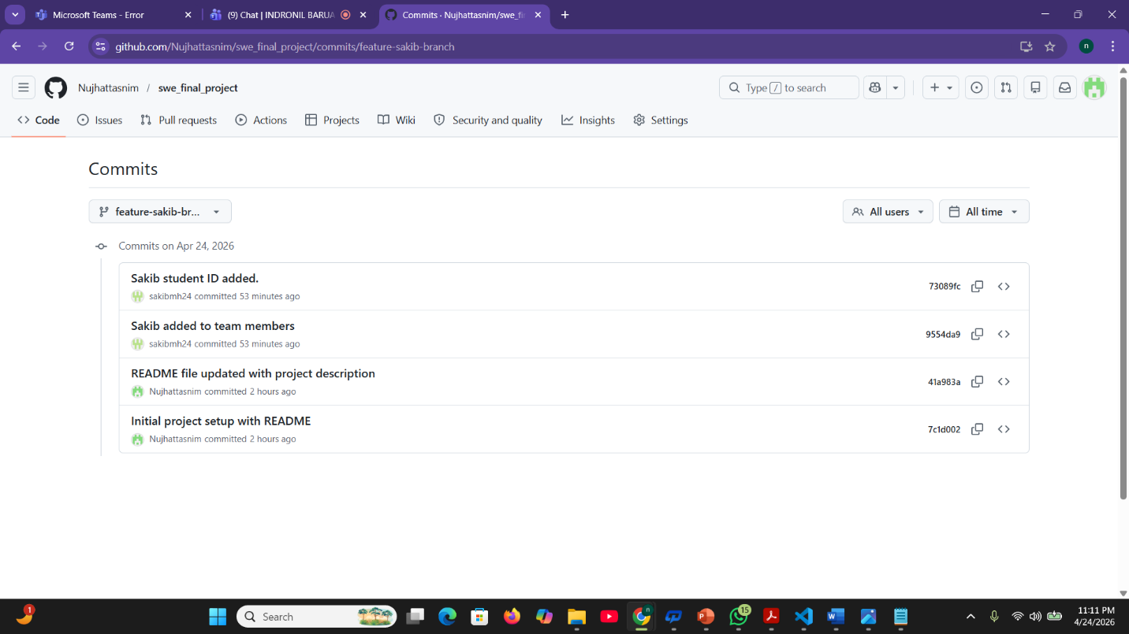

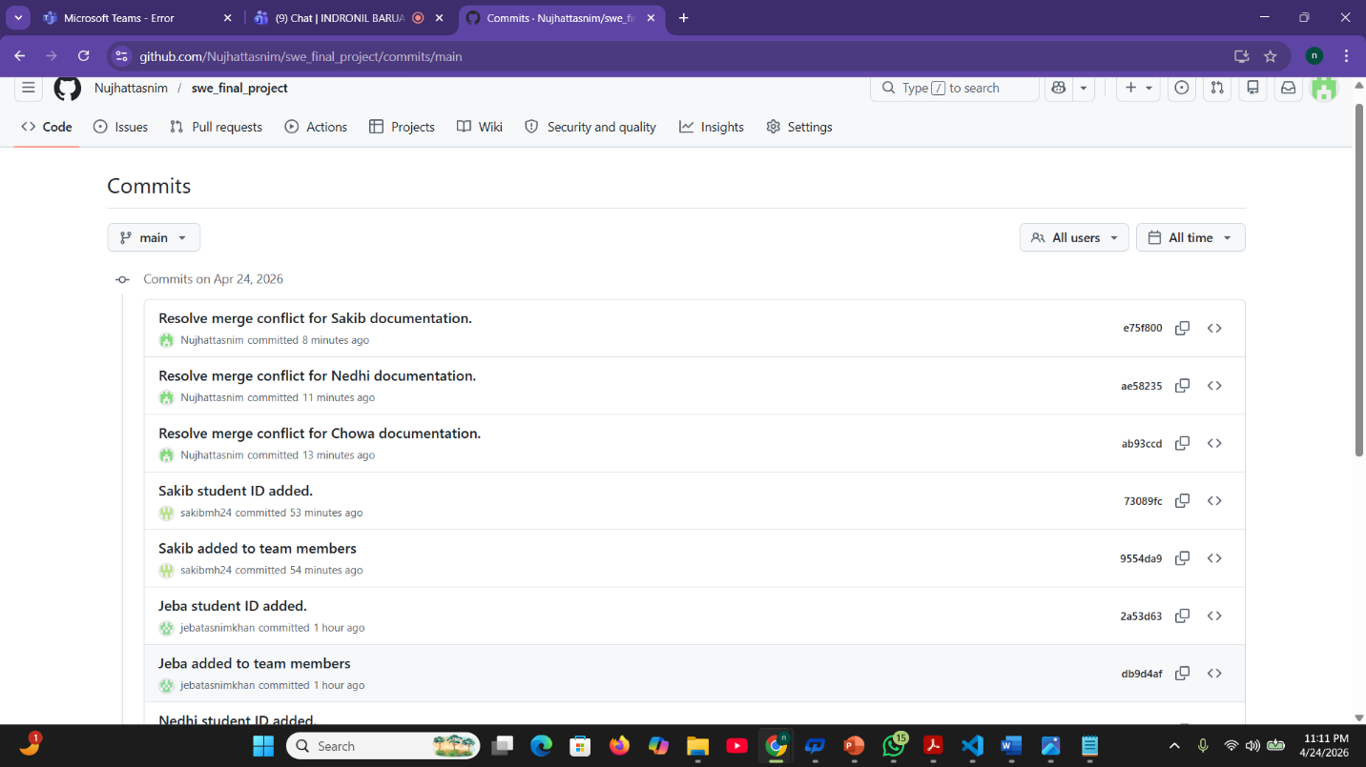
b) Screenshots of git commands for merging (merged by Nujhat Tasnim [23-53077-3])
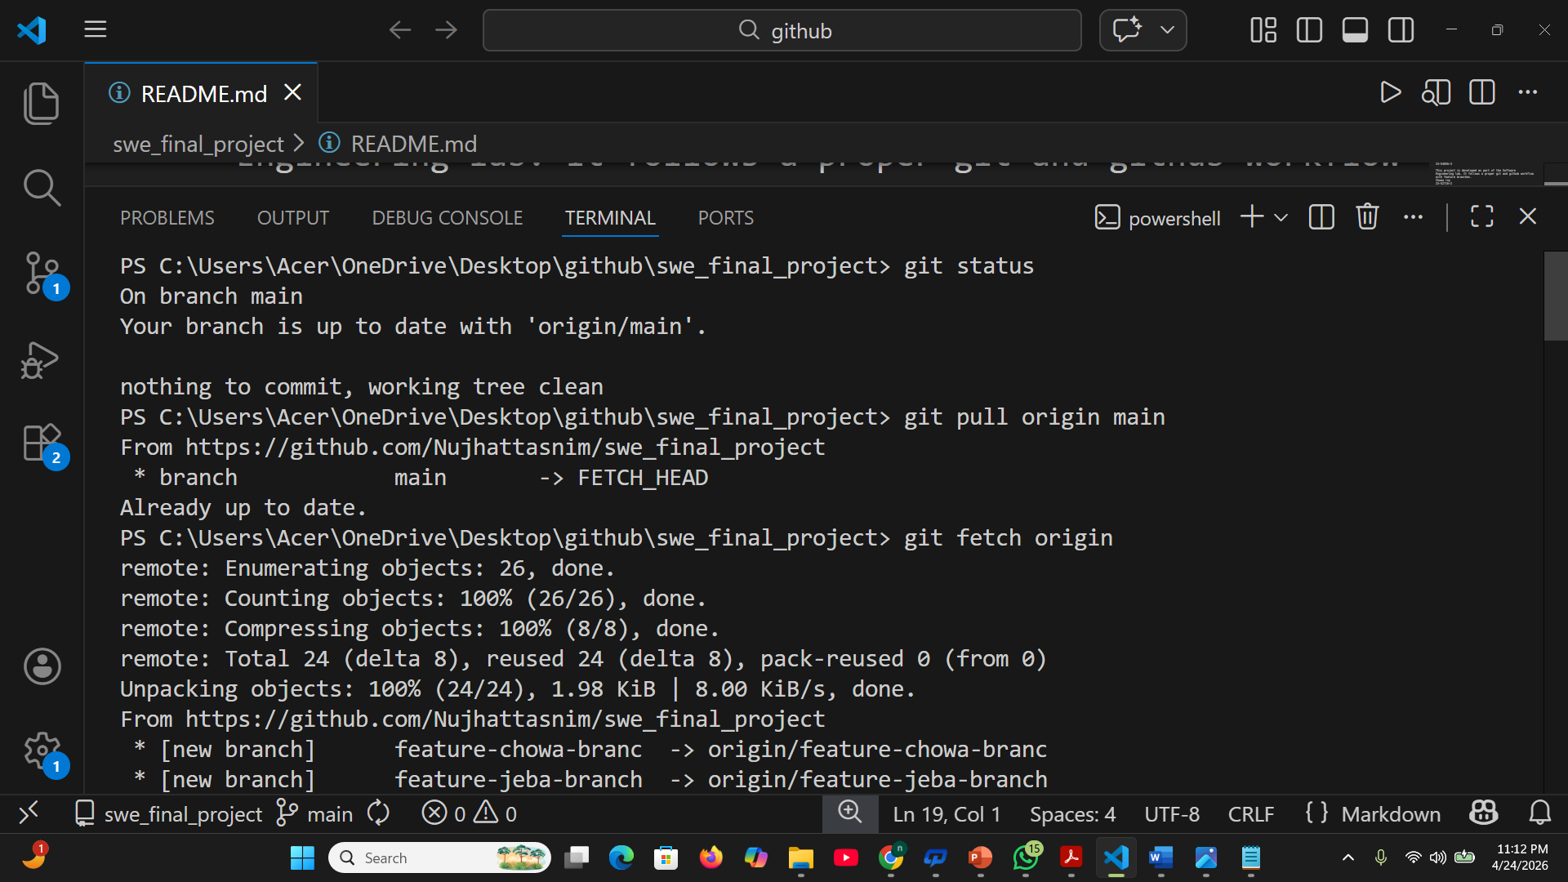
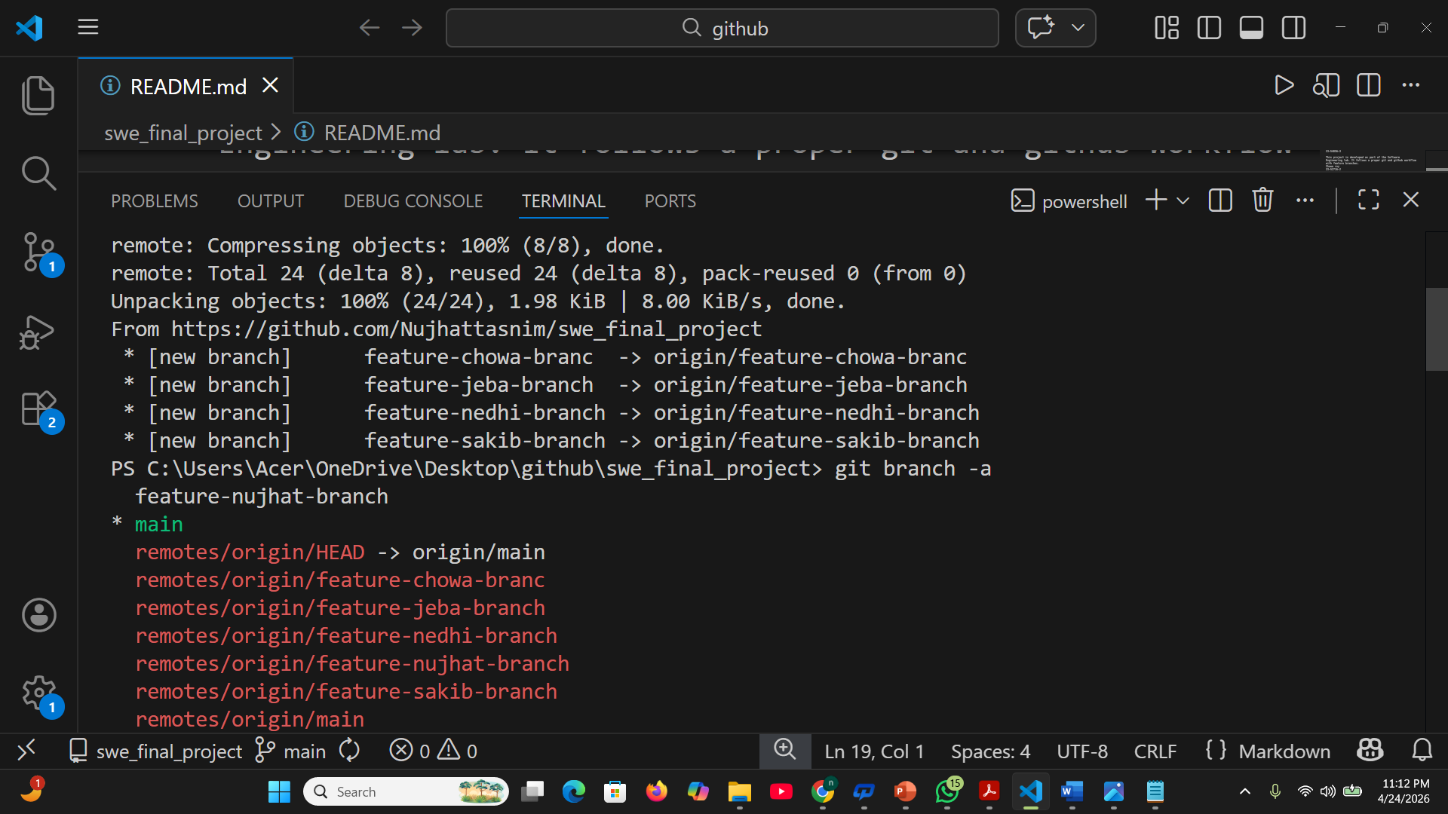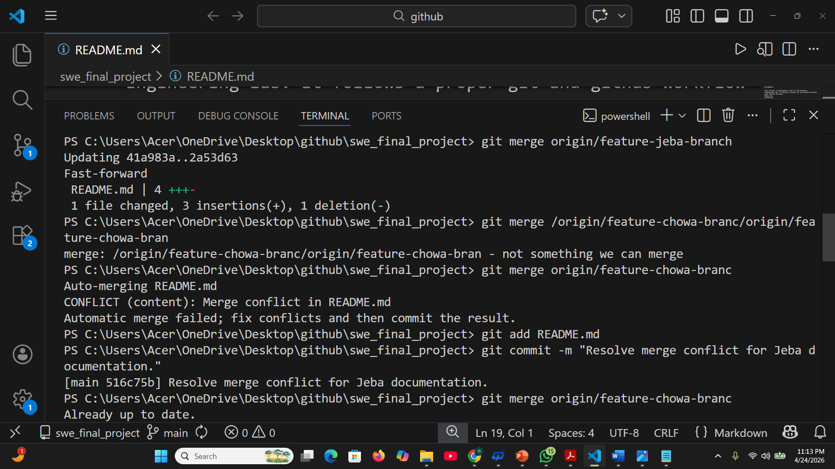

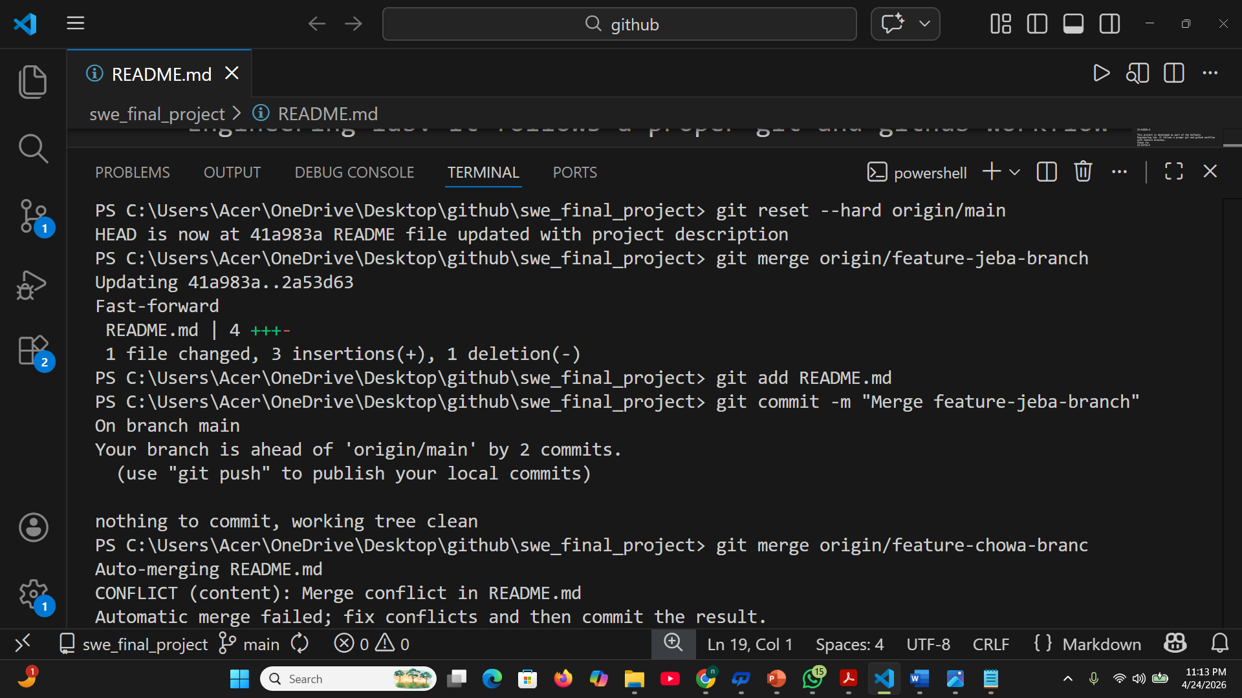
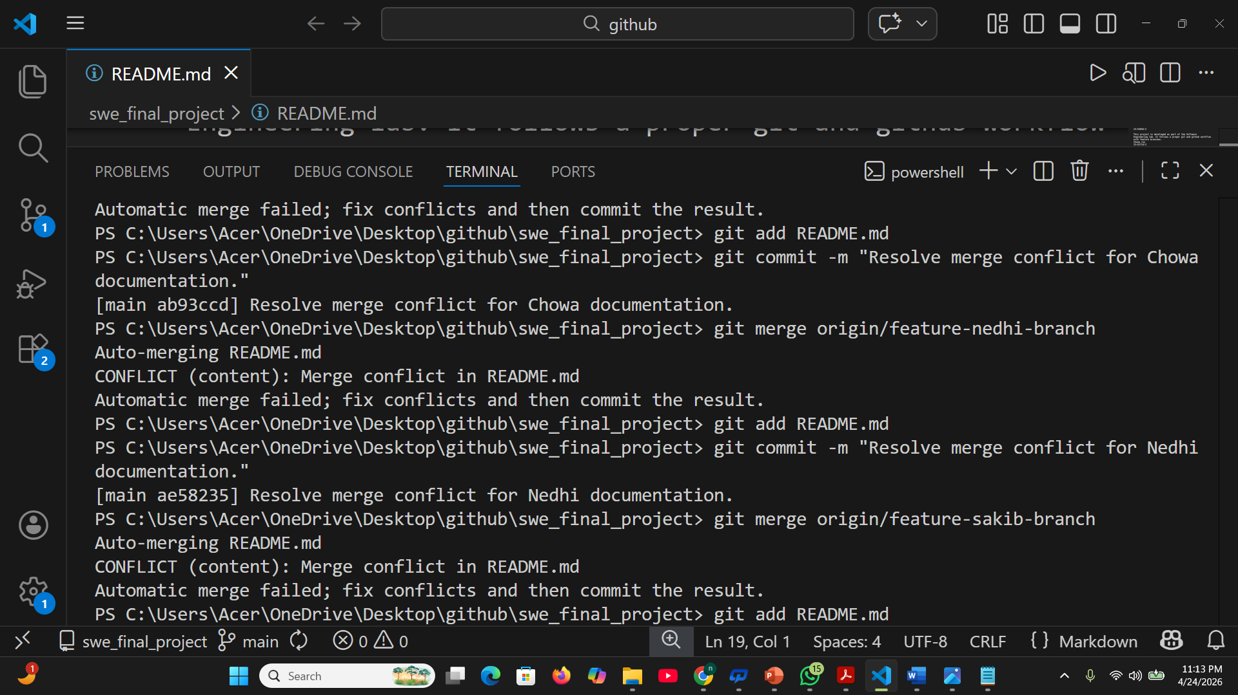

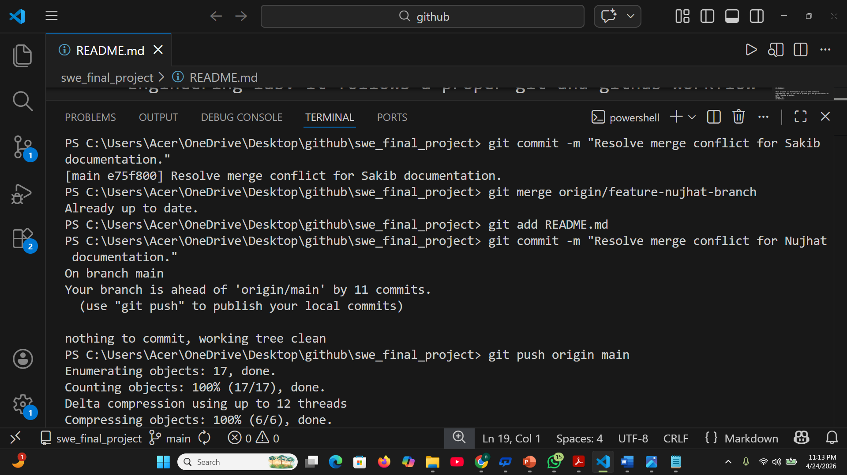
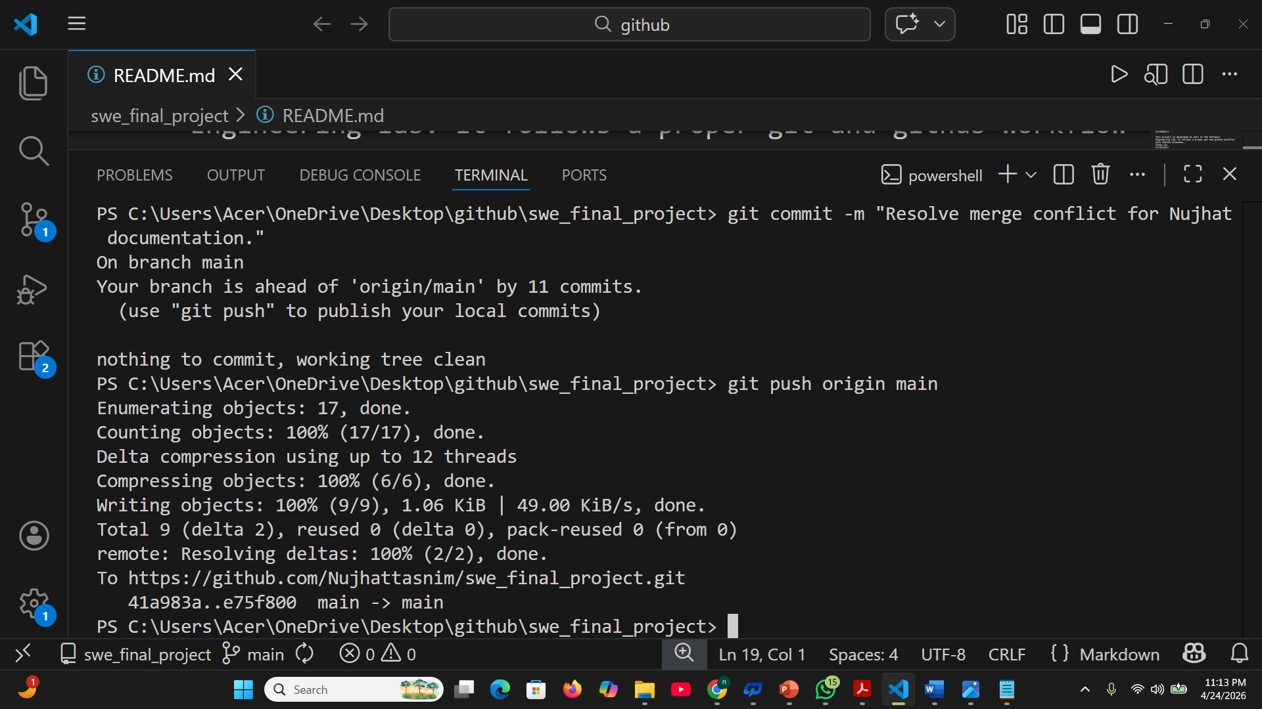

c) Cloning and creating feature branch commits by Nujhat Tasnim (23-53077-3)
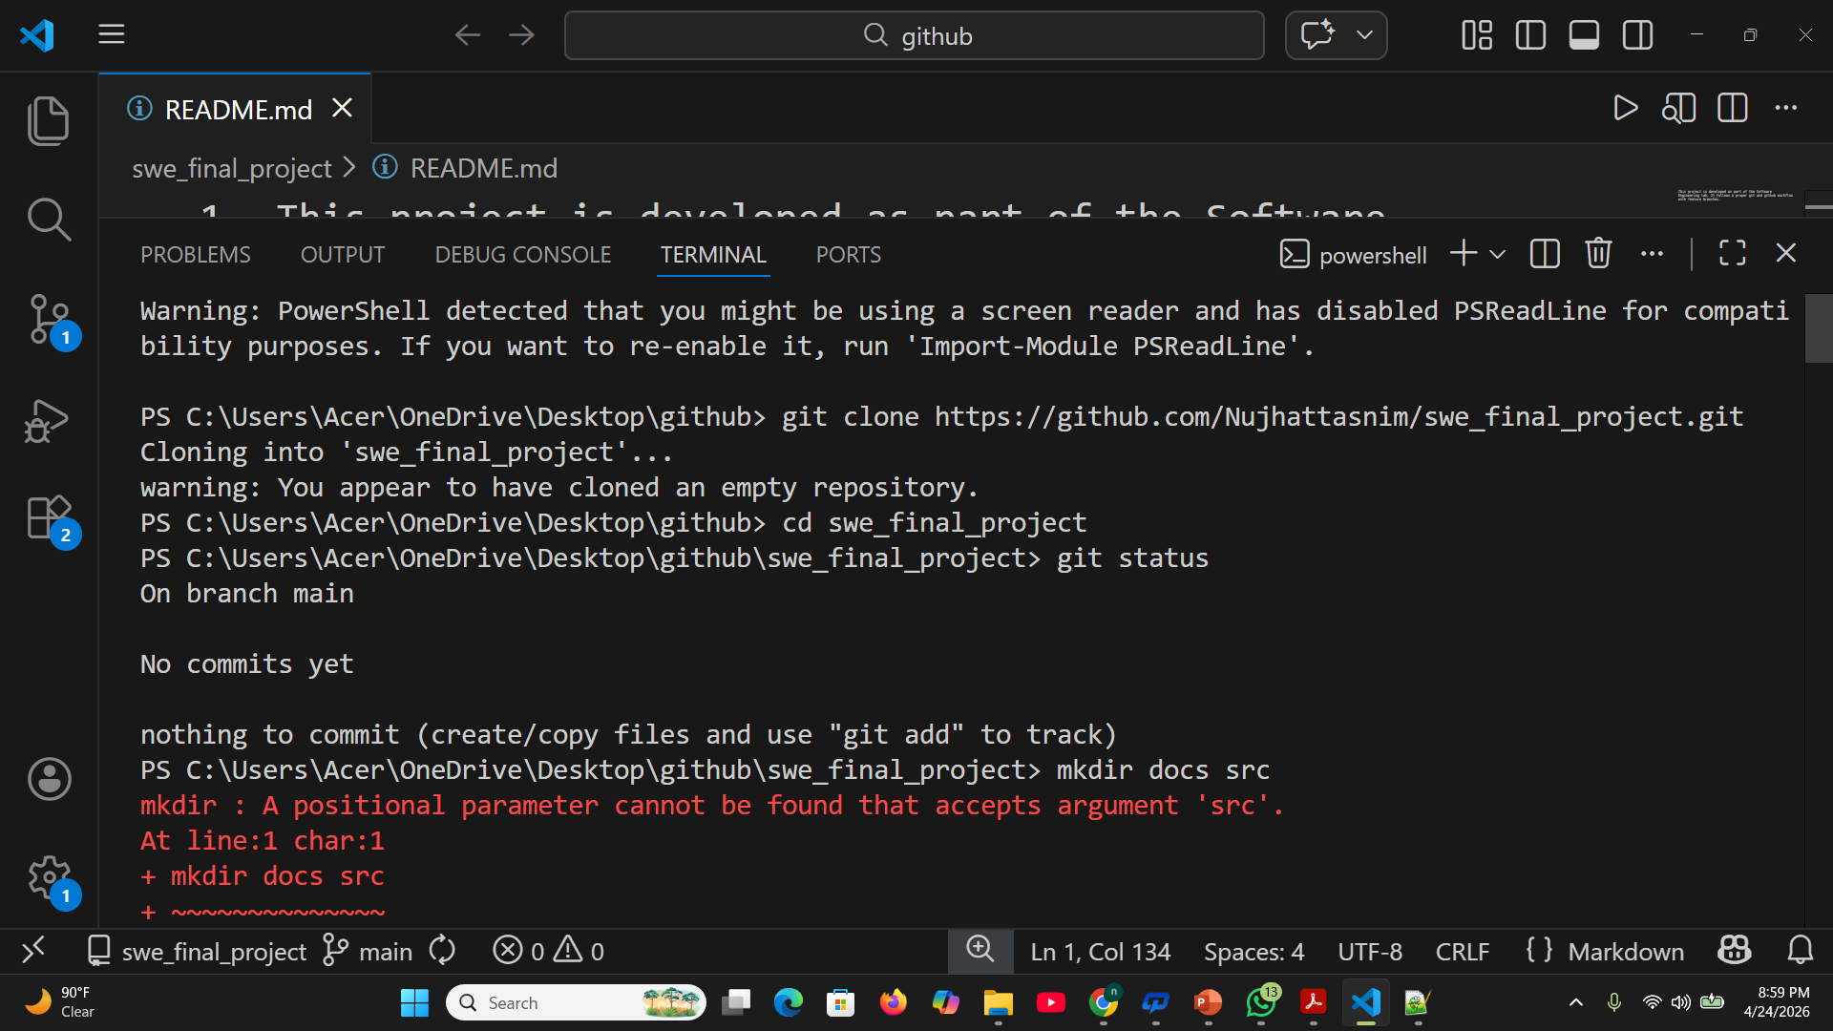
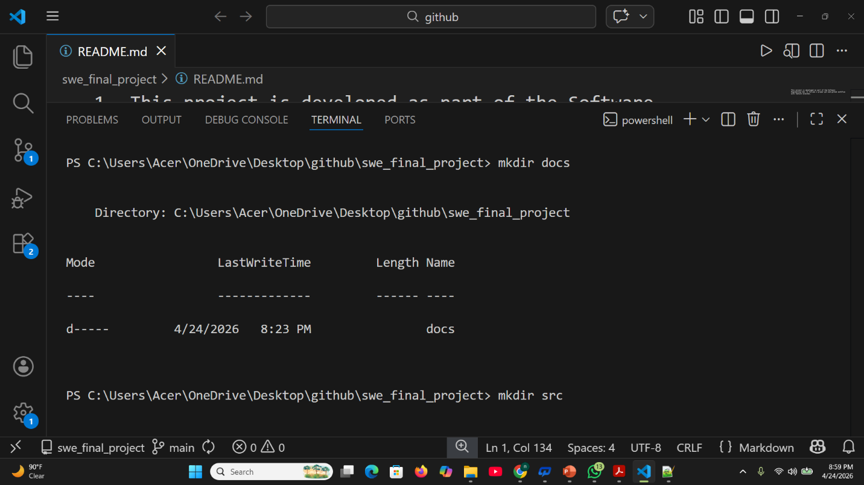
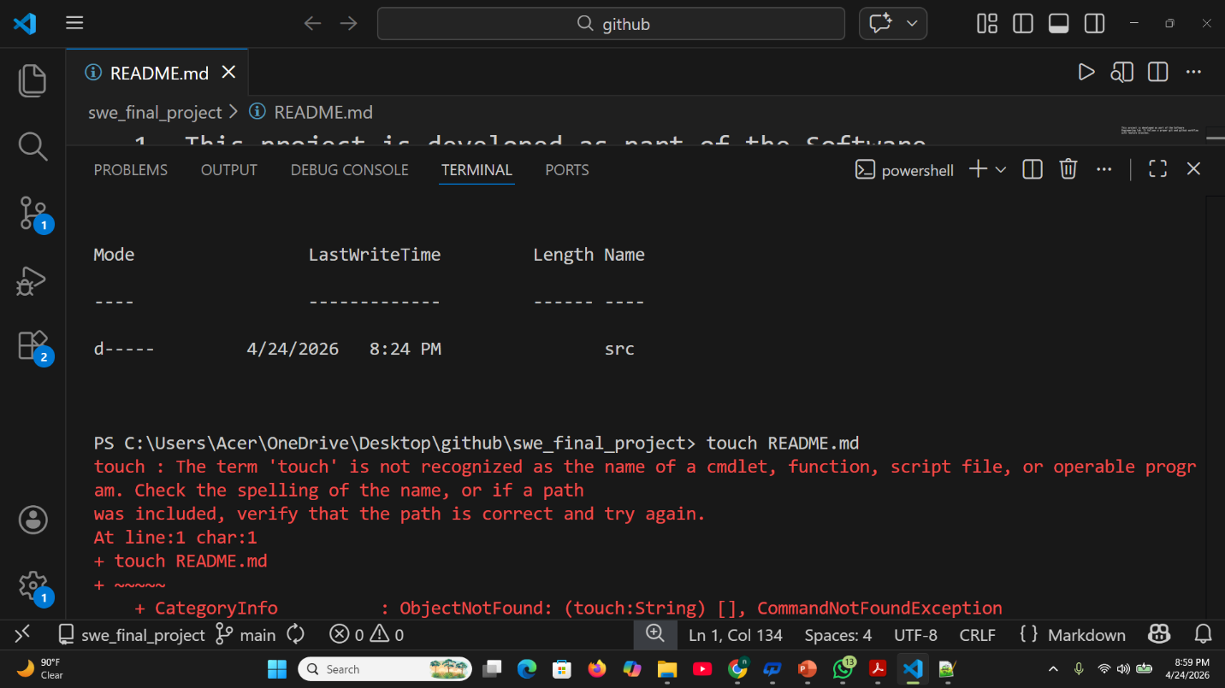
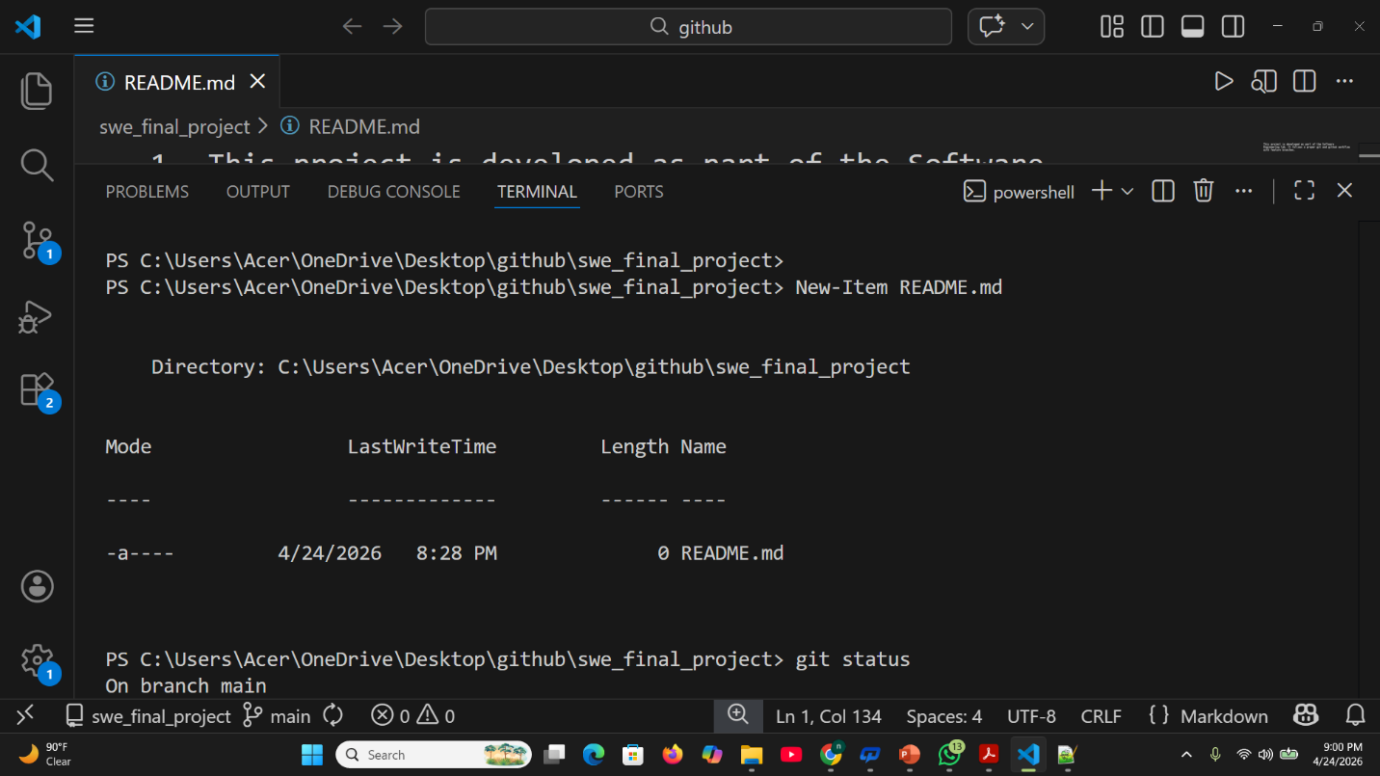

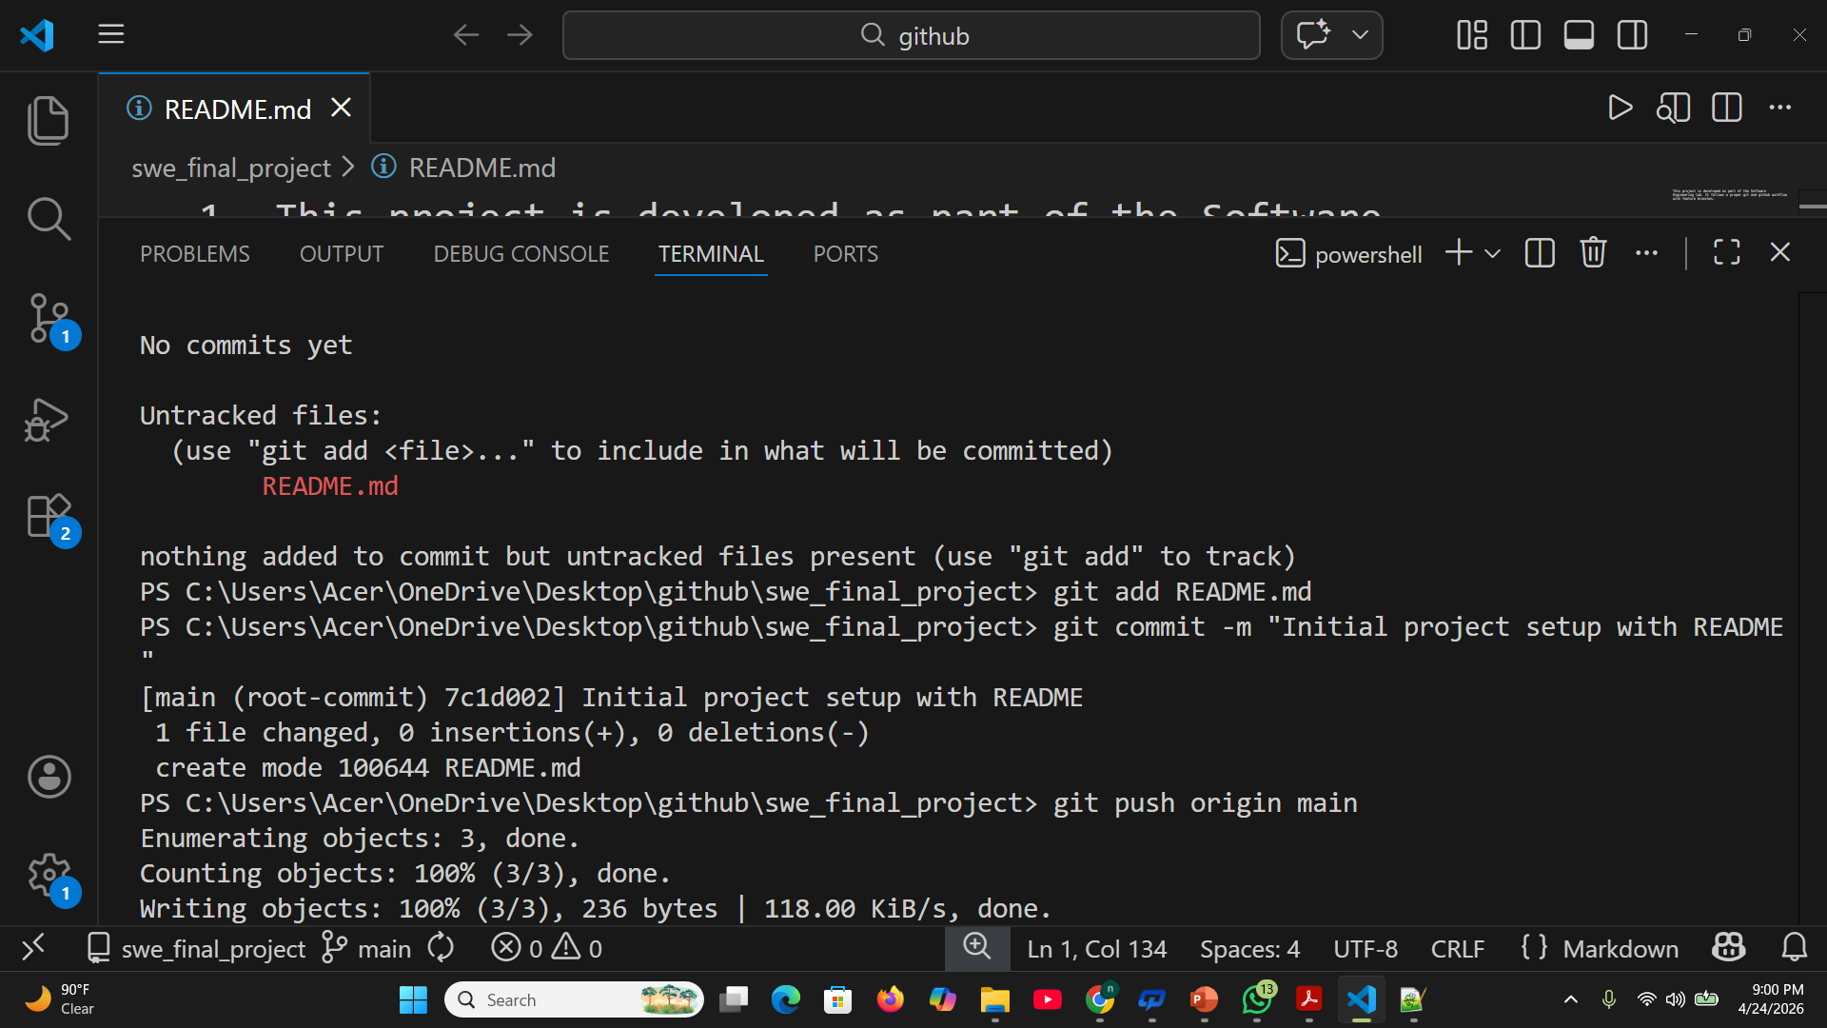
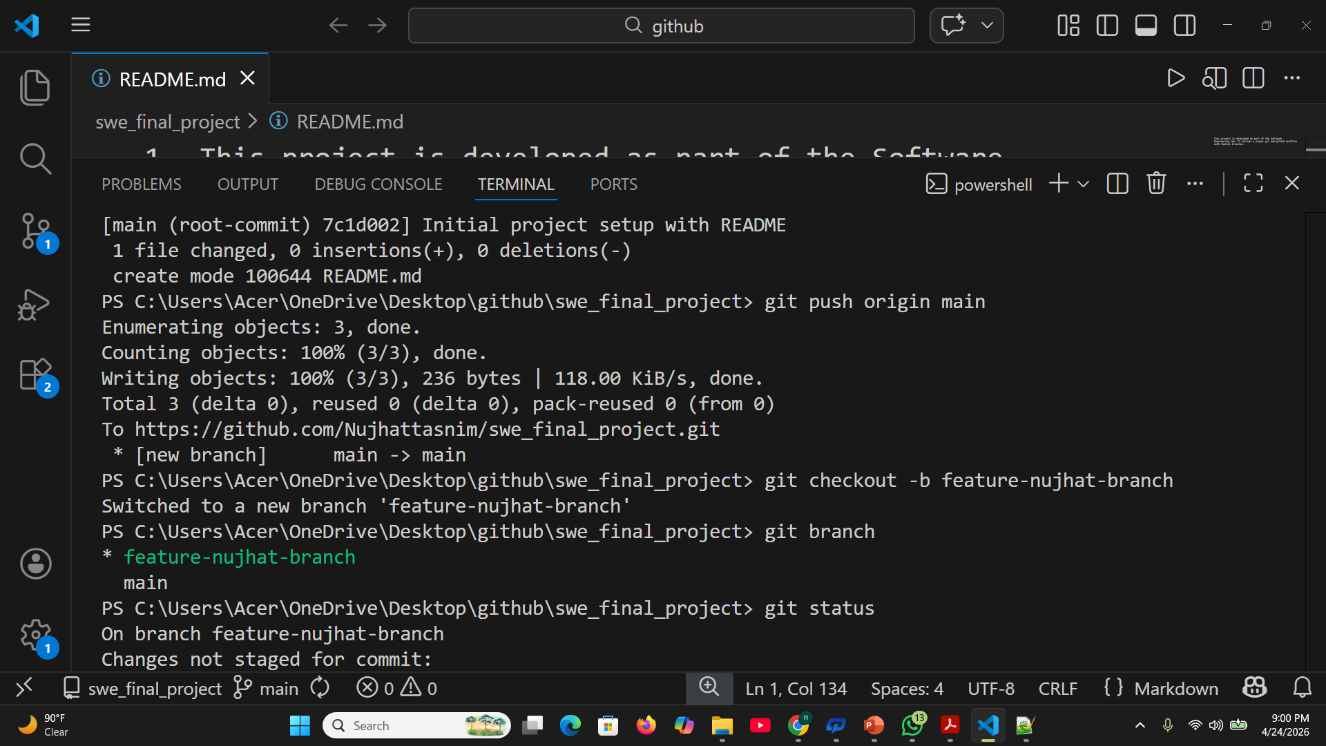

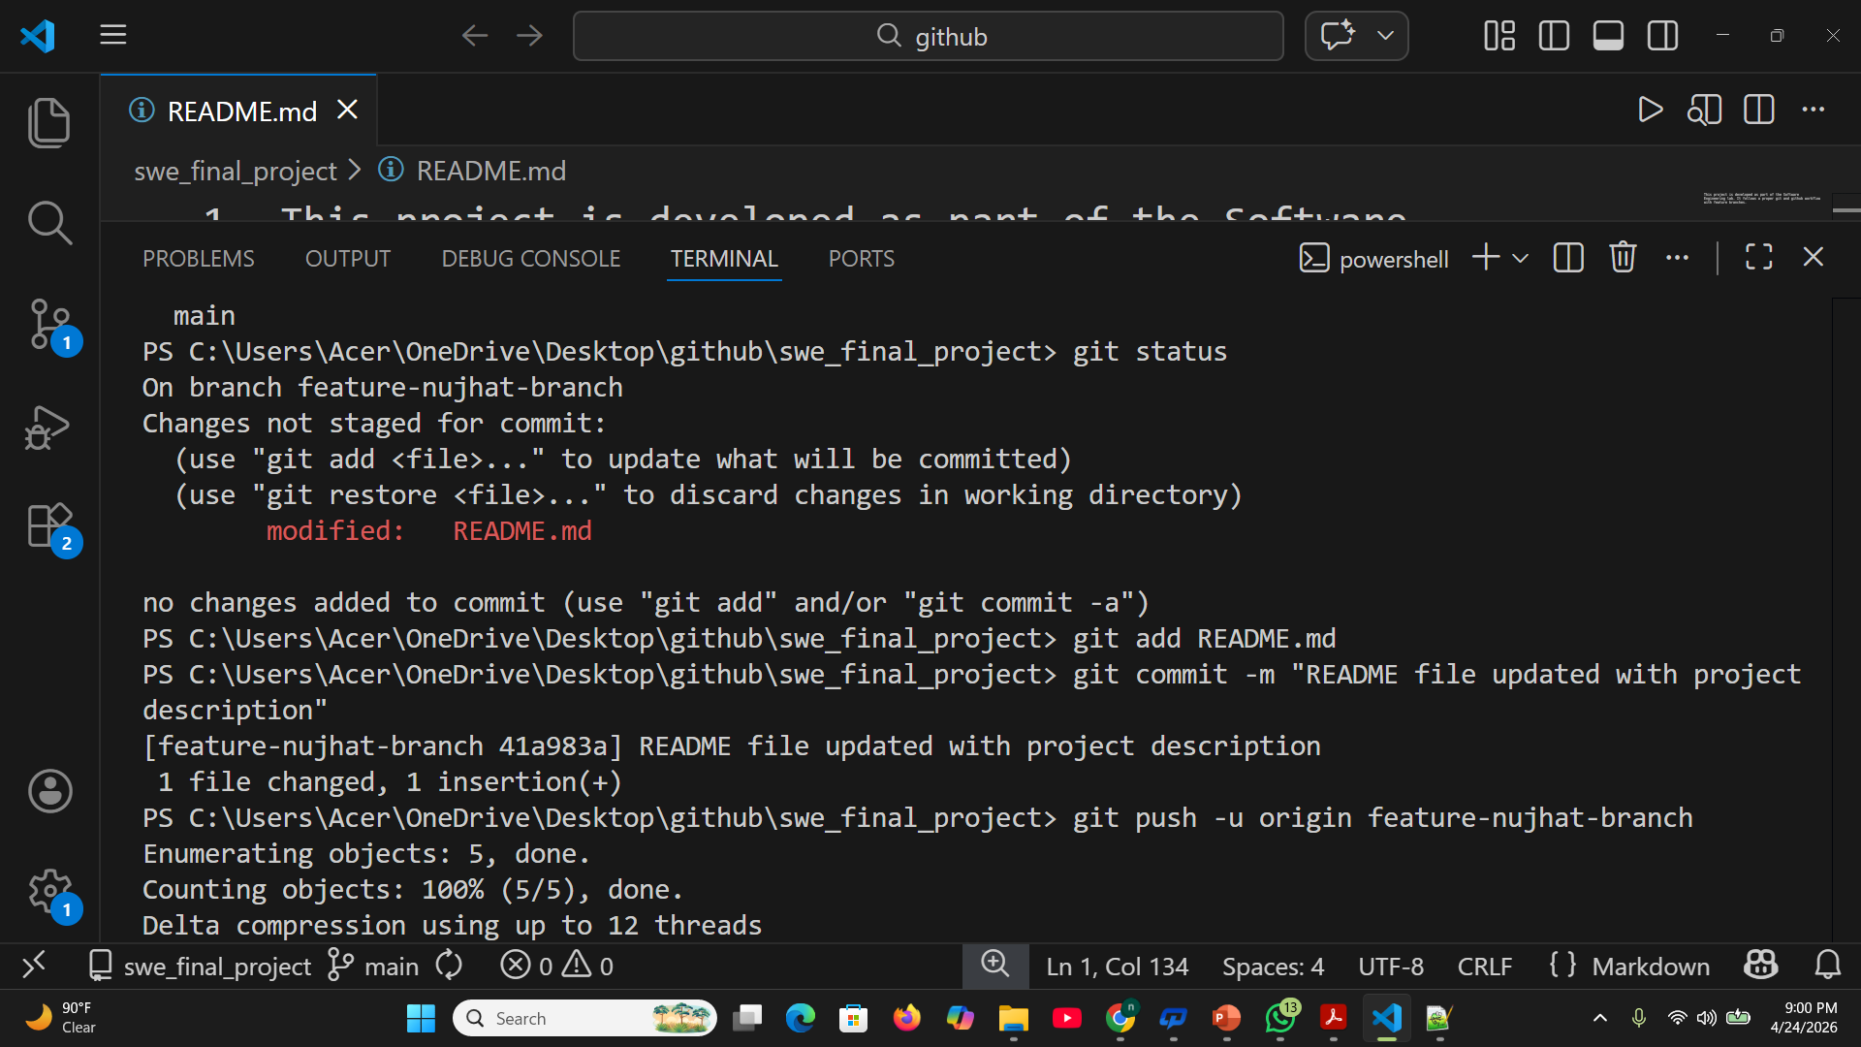
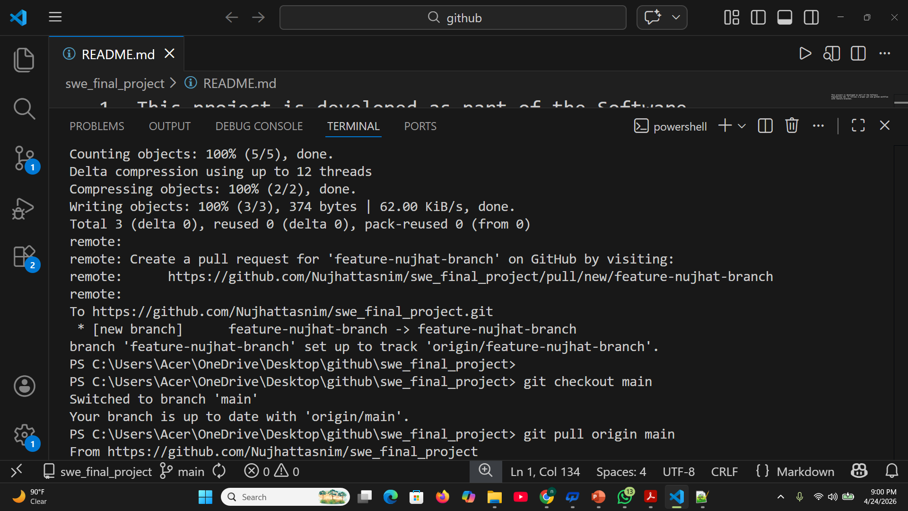

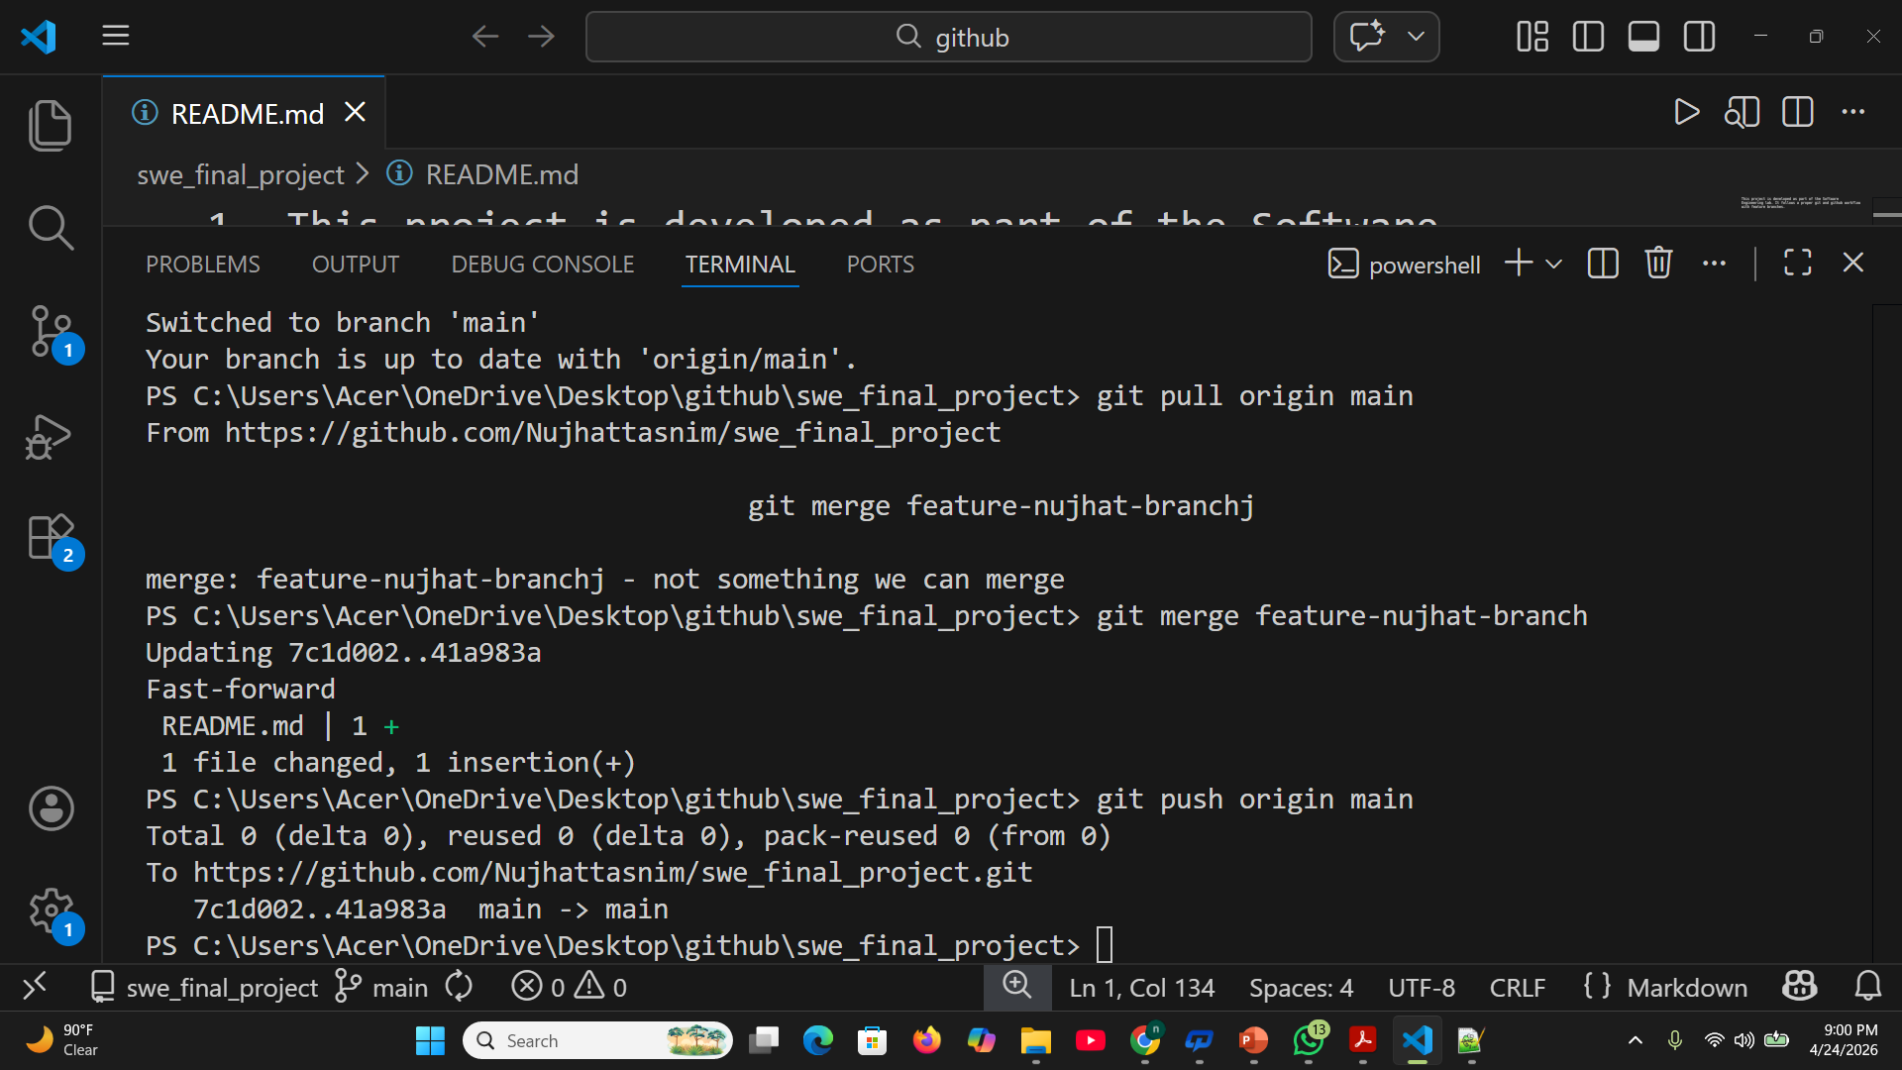
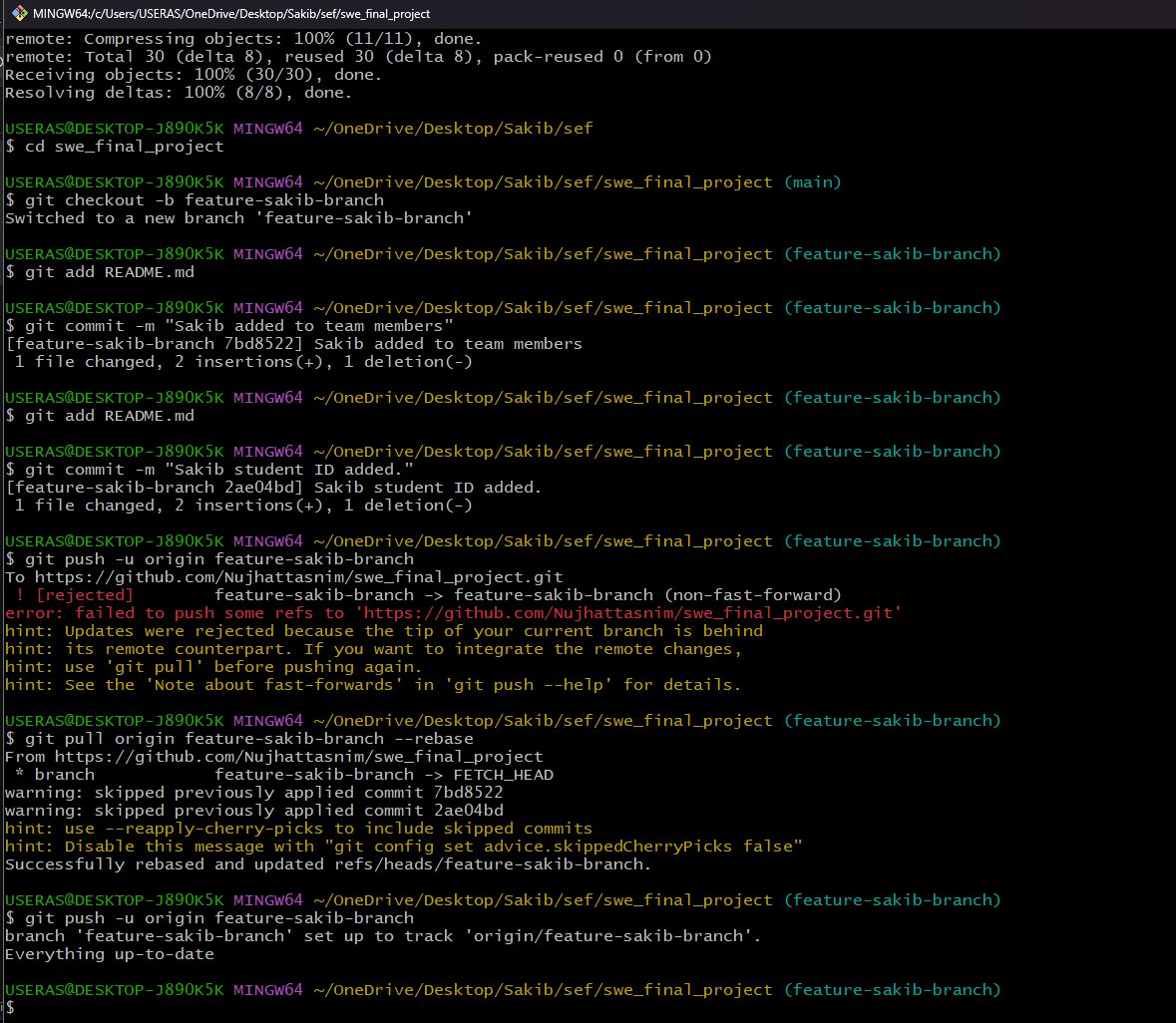
d) Cloning and creating feature branch commits by Sakib Monir Hossen (24-58473-2)

e) Cloning and creating feature branch commits by Jeba Tasnim Khan (23-54856-3)
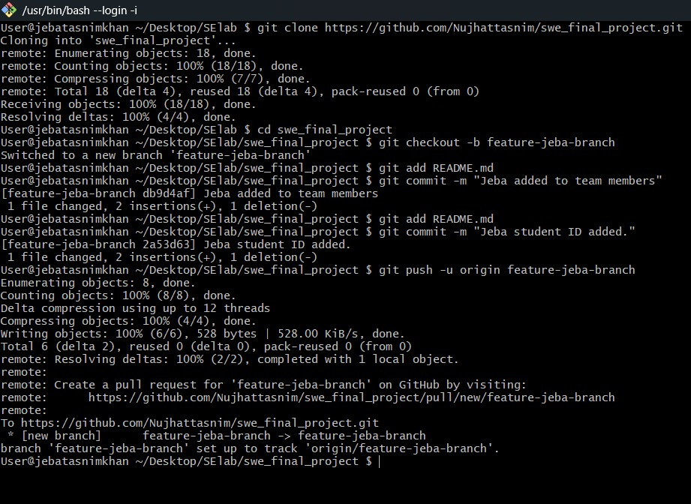

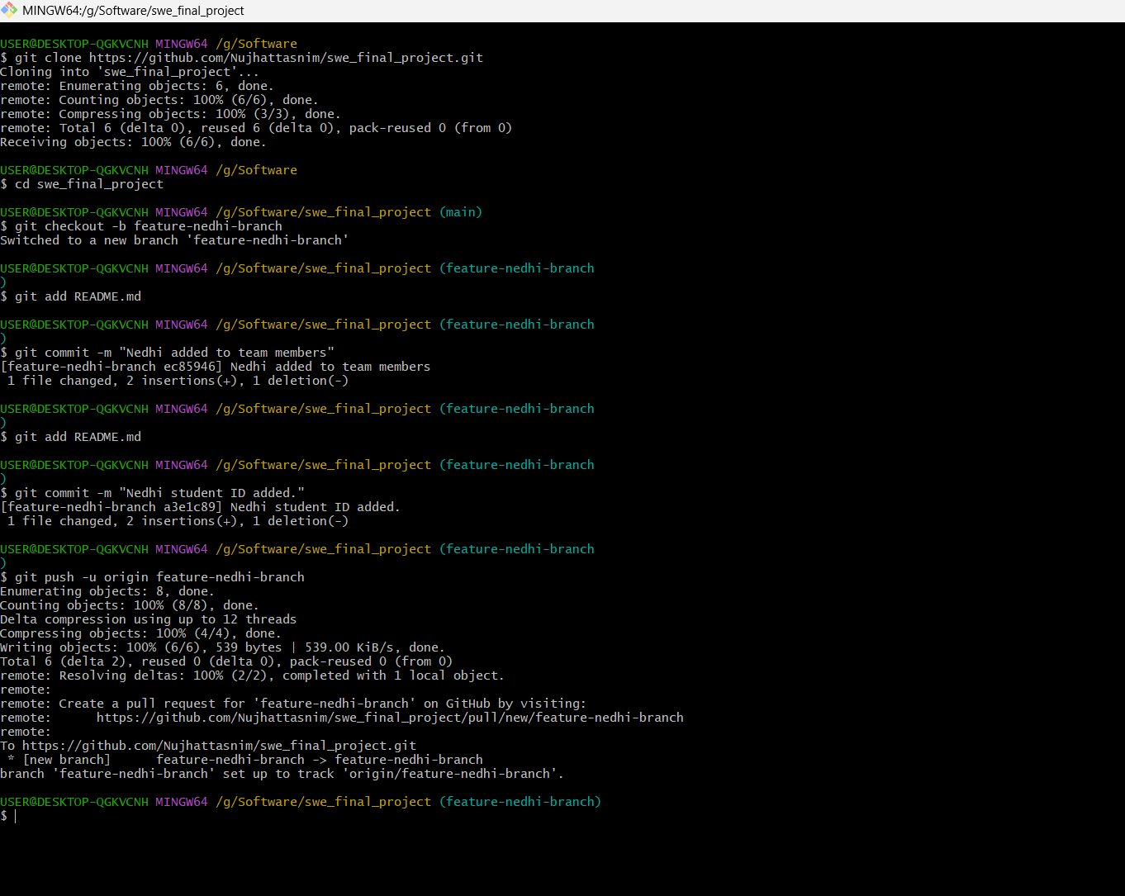
f) Cloning and creating feature branch commits by Fatema Nedhi(23-54451-3)

g) Cloning and creating feature branch commits by Chowa Roy (23-52716-3)
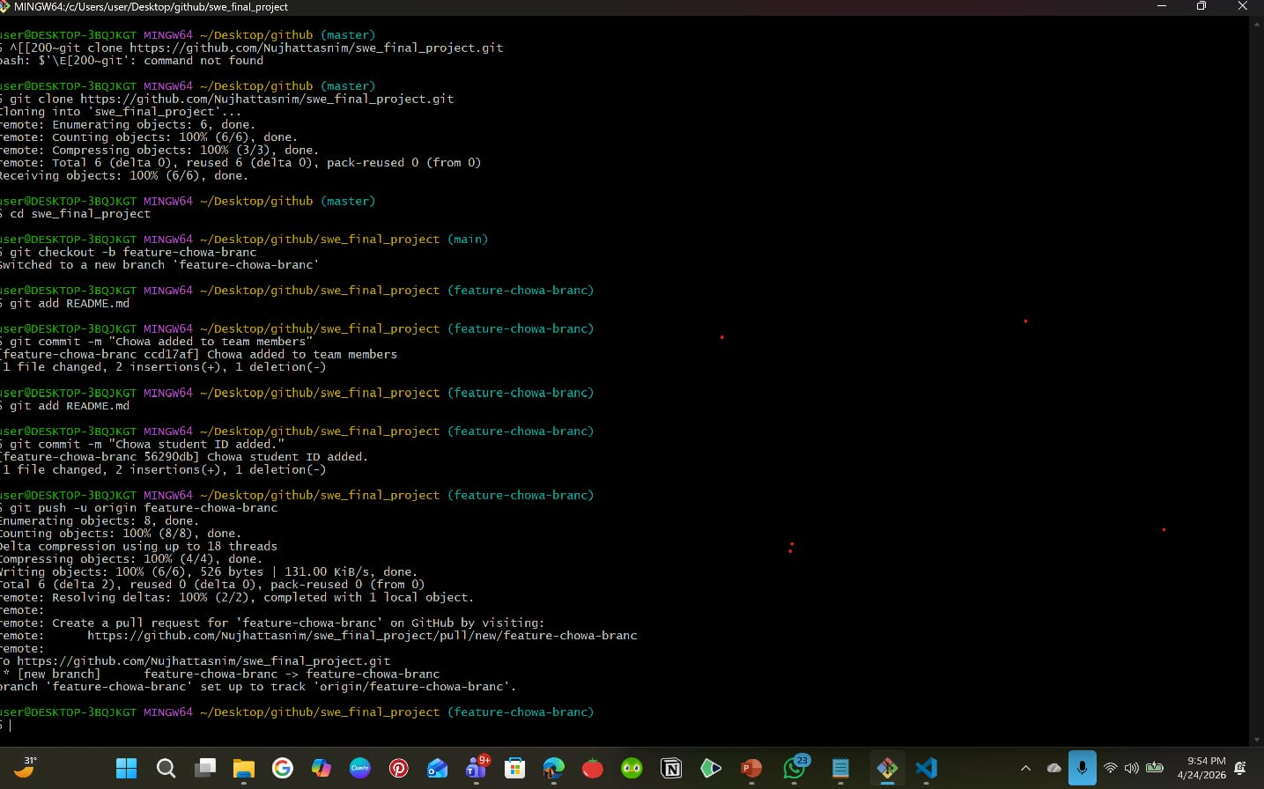
Github SWEFINALPROJECT repository link :
https://github.com/Nujhattasnim/swe_final_project

5. Software testing :
a) Testing methods that could be used in the testing phase for TechMart :
1. Unit testing : Unit testing is used to test individual modules or components of the system separately. Each function or module is tested to ensure it works correctly. TechMart has separate modules such as login, product management, inventory, sales, reports, and users. Unit testing helps to check each module individually before combining them. This makes it easier to find and fix errors early.
2. Integration testing : Integration testing is used to test the interaction between different modules after unit testing. It checks whether the combined modules work correctly together. In TechMart, modules depend on each other, such as login leading to dashboard access and product updates affecting inventory and reports. Integration testing ensures that data flows correctly between modules.
3. System testing : System testing tests the complete system as a whole. It checks whether the entire application works according to the specified requirements. TechMart is a complete desktop application. System testing ensures that all features such as login, sidebar navigation, product handling, sales tracking, and reporting work properly in the full system.
4. Regression testing : Regression testing is performed after changes or updates are made to the system. It checks whether new changes affect existing functionalities. During development of TechMart, updates may be made to fix bugs or add improvements. Regression testing ensures that previously working features continue to work correctly after changes.
5. Black-Box testing : Black-box testing focuses on testing the system based on functional requirements without looking at the internal code structure. TechMart features such as login, adding products, filtering sales, and adding users can be tested based on input and output. Black-box testing helps verify that the system meets functional requirements from the admin’s point of view.
6. Smoke testing : Smoke testing is used to check whether the basic and critical features of the system work after a new build. Smoke testing helps ensure that the TechMart application is stable and that core features like login and dashboard loading work before detailed testing begins.

(b) Test cases:
Project name : Book Shop Management System |  |  | Test designed by Nujhat Tasnim
Test case ID : TC_A_1 |  |  | Test designed date : 28/04/26
Test priority (Low, medium, high) : High |  |  | Test executed by : Fatema Abdden Nedhi
Module name : Admin Login |  |  | Test execution date : 28/04/26
Test title : Verify admin login with valid credentials.
Description : This test checks whether the admin can log in using valid username and password.
Precondition : Book Shop Management System application is running.
Dependencies (if any) : Database connection is active.
Test steps | Test data | Expected results |  | Actual results | Status (pass/fail)
1. Open application.  2. Enter valid username.  3. Enter valid password.  4. Click Login button. | Username: admin  Password: admin123 | 1. Login page loads successfully.  2. System verifies login details.  3. Admin dashboard is displayed. |  | As expected | Pass

Project name : Book Shop Management System |  |  | Test designed by Nujhat Tasnim
Test case ID : TC_A_2 |  |  | Test designed date : 28/04/26
Test priority (Low, medium, high) : High |  |  | Test executed by : Fatema Abdden Nedhi
Module name : Book Management |  |  | Test execution date : 28/04/26
Test title : Verify adding a new book.
Description : This test checks whether the admin can add a new book successfully.
Precondition : Admin is logged into the system.
Dependencies (if any) : Book database is available.
Test steps | Test data | Expected results |  | Actual results | Status (pass/fail)
1. Open book management panel.  2. Enter Book ID.  3. Enter Title.  4. Enter Author.  5. Enter Price.  6. Enter Quantity.  7. Click "Add" button. | Book ID: B101  Title: Harry Potter  Author: J.K. Rowling  Price: 650 TK  Quantity: 15 | 1. All fields are validated.  2. New book is added to the system.  3. Book appears in the book list.  4. Success message is shown. |  | As expected | Pass

Project name : Book Shop Management System |  |  | Test designed by Nujhat Tasnim
Test case ID : TC_A_3 |  |  | Test designed date : 28/04/26
Test priority (Low, medium, high) : High |  |  | Test executed by: Fatema Abdden Nedhi
Module name : Employee Management |  |  | Test execution date : 28/04/26
Test title : Verify adding a new employee.
Description : This test checks whether the admin can add a new employee successfully.
Precondition : Admin is logged into the system.
Dependencies (if any) : User database is available.
Test steps | Test data | Expected results |  | Actual results | Status (pass/fail)
1. Open employee panel.  2. Enter employee name.  3. Enter phone number.  4. Enter email.  5. Enter username.  6. Enter password.  7. Click "Add" button. | Name: Jeba Khan  Phone: 017123…..  Email: sarah@bookshop.com  Username: Jeba  Password: emp123 | 1. All fields are validated.  2. New employee is added to system.  3. Employee appears in users list.  4. Success message is shown. |  | As expected | Pass

Project name : Book Shop Management System |  |  | Test designed by Nujhat Tasnim
Test case ID : TC_A_4 |  |  | Test designed date : 28/04/26
Test priority (Low, medium, high) : High |  |  | Test executed by : Fatema Abdden Nedhi
Module name : Reports |  |  | Test execution date : 28/04/26
Test title : Verify viewing sales reports and charts..
Description : This test checks whether the admin can view total sales, total profit, and best selling books with charts.
Precondition : Admin is logged into the system and sales data exists.
Dependencies (if any) : Sales database is active.
Test steps | Test data | Expected results |  | Actual results | Status (pass/fail)
1. Login as admin.  2. Navigate to Reports section.  3. Open reports page.  4. Apply date filter. | Sales records from database | 1. Total sales amount is displayed correctly.  2. Total profit is calculated accurately.  3. Best selling books chart loads correctly.  4. Filter by date range works properly. |  | Sales numbers are displayed, but charts fail to load and show blank screen. | Fail

Project name : Book Shop Management System |  |  | Test designed by Fatema Abdden Nedhi
Test case ID : TC_B_6 |  |  | Test designed date : 29/04/26
Test priority (Low, medium, high) : High |  |  | Test executed by : Nujhat Tasnim
Module name : Book Management |  |  | Test execution date : 29/04/26
Test title : Verify admin can update existing book information.
Description : This test checks whether the admin can edit and save changes to a book's details.
Precondition : Admin is logged in. A book already exists.
Dependencies (if any) : Book database is available.
Test steps | Test data | Expected results |  | Actual results | Status (pass/fail)
1.Navigate to Book List.  2. Select a book and click Edit.  3. Change Price to 700 TK.  4. Change Quantity to 12.  5. Click Update button. | Book ID: B101  New Price: 700 TK  New Quantity: 12 | 1.Selected book details load in edit form.  2. Fields can be modified.  3. Validation passes (positive numbers).  4. On save, database is updated.  5. Success message appears.  6. Updated info shows in book list. |  | As expected | Pass

Project name : Book Shop Management System |  |  | Test designed by Fatema Abdden Nedhi
Test case ID : TC_A_7 |  |  | Test designed date : 29/04/26
Test priority (Low, medium, high) : High |  |  | Test executed by: Nujhat Tasnim
Module name : Book Management |  |  | Test execution date : 29/04/26
Test title : Verify admin can delete a book from the system..
Description : This test checks whether the admin can remove a book permanently after confirmation.
Precondition : Admin is logged in. A book exists.
Dependencies (if any) : Book database is active.
Test steps | Test data | Expected results |  | Actual results | Status (pass/fail)
1.Navigate to Book List.  2. Select a book and click Delete.  3. Confirm by clicking Yes. | Book ID: B101  Title: Harry Potter | 1.Confirmation popup opens.  2. Clicking Yes removes book from database.  3. Book no longer appears in book list or search.  4. Success message is shown. |  | As expected | Pass

Project name : Book Shop Management System |  |  | Test designed by Fatema Abdden Nedhi
Test case ID : TC_B_8 |  |  | Test designed date : 29/04/26
Test priority (Low, medium, high) : High |  |  | Test executed by : Nujhat Tasnim
Module name : Sales Records |  |  | Test execution date : 29/04/26
Test title : Verify admin can view all sales transactions.
Description : This test checks whether the admin can see the complete sales history table and sort by date.
Precondition : Admin is logged in. Multiple sales transactions exist in database.
Dependencies (if any) : Sales database is active.
Test steps | Test data | Expected results |  | Actual results | Status (pass/fail)
1.Navigate to Sales Records from menu.  2. View the list of sales.  3. Click on Date column to sort. | Sales records from last 7 days | 1.Sales table loads with all transactions.  2. Columns show Sale ID, Employee, Customer, Total, Date.  3 .Sorting by date works (oldest to newest or vice versa). |  | Sales table loads, but sort by date does not reorder rows properly. | Fail

Project name : Book Shop Management System |  |  | Test designed by Nujhat Tasnim
Test case ID : TC_D_1 |  |  | Test designed date : 28/04/26
Test priority (Low, medium, high) : High |  |  | Test executed by :Sakib Monir Hossen
Module name : Supplier Management |  |  | Test execution date : 28/04/26
Test title : Verify admin can add a new supplier successfully.
Description : This test checks whether the admin can add a new supplier with valid details.
Precondition : Admin is logged into the system.
Dependencies (if any) : Supplier database is available.

Test steps | Test data | Expected results |  | Actual results | Status (pass/fail)
- Open supplier panel.  - Enter name.  - Enter phone.  - Enter email.  - Enter address.  6. Click Add. | Name: Readers Hub, Phone: 01345678987, Email:readershub@gmail.com, Address: F block,Bashundara | - Fields validated.  - Supplier added.  - Appears in list.  4. Success message. |  | As expected | Pass

Project name : Book Shop Management System |  |  | Test designed by Nujhat Tasnim
Test case ID : TC_D_2 |  |  | Test designed date : 28/04/26
Test priority (Low, medium, high) : High |  |  | Test executed by : Sakib Monir Hossen
Module name : Admin Account |  |  | Test execution date : 28/04/26
Test title : Verify admin cannot change password with incorrect old password.
Description : This test checks whether system blocks password change when old password is wrong.
Precondition : Admin is logged into the system.
Dependencies (if any) : None.
Test steps | Test data | Expected results |  | Actual results | Status (pass/fail)
- Go to profile.  - Click Change Password.  - Enter wrong old password.  - Enter new password.  - Confirm.  6. Click Save.. | Old: wrong123, New: newPass456, Confirm: newPass456 | Error: "Old password is incorrect". Password unchanged. |  | System accepted change and showed "Password updated" despite wrong old password. | FAIL

Project name : Book Shop Management System |  |  | Test designed by Nujhat Tasnim
Test case ID : TC_D_3 |  |  | Test designed date : 28/04/26
Test priority (Low, medium, high) : Medium |  |  | Test executed by: Sakib Monir Hossen
Module name : Supplier Books |  |  | Test execution date : 28/04/26
Test title : Verify supplier can view only their supplied books.
Description : This test checks that a supplier sees only books they supplied.
Precondition : Supplier is logged in. Supplier has supplied books.
Dependencies (if any) : Database has books from multiple suppliers.
Test steps | Test data | Expected results |  | Actual results | Status (pass/fail)
- Login as supplier (Readers Hub).  2. Go to "My Supplied Books". 3. View list. | Supplier: Readers Hub | Only Readers Hub books appear. Other suppliers' books not shown |  | As expected | Pass

Project name : Book Shop Management System |  |  | Test designed by Nujhat Tasnim
Test case ID : TC_D_4 |  |  | Test designed date : 28/04/26
Test priority (Low, medium, high) : High |  |  | Test executed by : Sakib Monir Hossen
Module name : Supplier Alerts |  |  | Test execution date : 28/04/26
Test title : Verify supplier receives low stock alert.
Description : This test checks if system alerts supplier when stock is below minimum.

Precondition : Supplier logged in. One supplied book has stock ≤ 5.
Dependencies (if any) : ow stock threshold is set to 5.

Test steps | Test data | Expected results |  | Actual results | Status (pass/fail)
- Login as supplier.  - Go to dashboard.  3. Check low stock alerts. | Book: Harry Potter,  Stock: 3, Threshold: 5 | Alert appears with book name and stock quantity. |  | As expected | Pass

Project name: Book Shop Management System |  |  | Test designed by Chowa roy
Test case ID: TC_C_1 |  |  | Test designed date: 28/04/26
Test priority (Low, medium, high) : High |  |  | Test executed by: Nujhat Tasnim
Module name: Customer Registration (Signup) |  |  | Test execution date: 28/04/26
Test title: Verify customer can register with valid credentials
Description: This test checks whether a new customer can create an account using valid information.
Precondition: Application is running. Customer is not logged in. Database connection is active.
Dependencies (if any): Email must not already exist in the database.
Test steps | Test data | Expected results |  | Actual results | Status (pass/fail)
- Open the application and click the Signup link  - Enter Name  - Enter Phone  - Enter Email  - Enter Password  - Enter Re-password  - Click the Signup button | Name: Shaila Ahmed  Phone: 01712345688  Email: shaila@gmail.com  Password:pass123 Re-password: pass123 | 1. Signup form loads with all fields  2. Phone (11 digits) validation passes 3. Email format validation passes  4. Password (min 6 chars) validation passes 5. Re-password matches password  6. Customer data saved to the database  7. Redirected to the customer login page  8. Success message shown |  | As expected | Pass

Project name : Book Shop Management System |  |  | Test designed by Chowa roy
Test case ID : TC_C_2 |  |  | Test designed date : 28/04/26
Test priority (Low, medium, high) : High |  |  | Test executed by : Nujhat Tasnim
Module name: Customer Login (Signin) |  |  | Test execution date : 28/04/26
Test title: Verify customer can log in with valid credentials
Description: This test checks whether a registered customer can log in using a valid email and password.
Precondition: Customer account exists in the database. The application is on the login page.
Dependencies (if any): Database connection is active.
Test steps | Test data | Expected results |  | Actual results | Status (pass/fail)
1. Open application 2. Enter a valid Email 3. Enter a valid Password  4. Click the Sign In button | Username/Email: shaily@gmail.com  Password: pass123 | 1. Login page loads  2. Credentials verified against the database  3. Customer dashboard opens successfully  4. Menu shows customer-specific options (Browse Books, Search Books, My Purchase History, etc.) |  | As expected | Pass

Project name: Book Shop Management System |  |  | Test designed by Chowa roy
Test case ID: TC_C_3 |  |  | Test designed date: 28/04/26
Test priority (Low, medium, high): Medium |  |  | Test executed by: Nujhat Tasnim
Module name: Browse & Search Books |  |  | Test execution date: 28/04/26
Test title : Verify customer can search books by title
Description: This test checks whether a customer can search for books using the search box by title.
Precondition: Customer is logged into the system. Books exist in the database.
Dependencies (if any): Book database is available.
Test steps | Test data | Expected results |  | Actual results | Status (pass/fail)
1. Customer logged in, navigate to Browse Books 2. Enter book title in search box  3. Click Search button | Search term: "Harry Potter" | 1. Book list displays all books  2. Search filters results by title  3. Only books containing "Harry Potter" in title appear  4. Each result shows title, author, price |  | As expected | Pass

Project name: Book Shop Management System |  |  | Test designed by Chowa roy
Test case ID: TC_C_4 |  |  | Test designed date: 28/04/26
Test priority (Low, medium, high) : High |  |  | Test executed by: Nujhat Tasnim
Module name: Customer Purchase History |  |  | Test execution date: 28/04/26
Test title : Verify customer can view their purchase history
Description: This test checks whether a customer can see their own purchase history after making purchases.
Precondition: Customer is logged into the system. The customer has made at least 2 past purchases.
Dependencies (if any): Sales database is active. Customer ID must be correctly linked to sales records.
Test steps | Test data | Expected results |  | Actual results | Status (pass/fail)
1. Login as customer (shaila@gmail.com) 2. Click on "My Purchase History" from the menu  3. Verify table columns | Customer: Shaila Ahmed  Past purchases exist in the database | 1. Purchase history loads with Date, Book, Quantity, Price columns 2. Shows correct purchase records with accurate data 3. Records are sorted by date (newest first)  4. Total books purchased count matches |  | Purchase history page loads, but shows "No records found" message | Fail

Project name : Book Shop Management System |  |  | Test designed by Jeba Tasnim Khan
Test case ID : TC_EMP_1 |  |  | Test designed date : 28/04/26
Test priority (Low, medium, high) : High |  |  | Test executed by : Jeba Tasnim Khan
Module name : Employee Login(Auth Feature) |  |  | Test execution date : 28/04/26
Test title : Verify employee login with valid credentials.
Description : This test checks whether an employee can log in using valid username and password.
Precondition : Book Shop Management System application is running. Employee account exists in database.
Dependencies (if any) : Database connection is active.
Test steps | Test data | Expected results |  | Actual results | Status (pass/fail)
1.Open application.  2.Click on Signin button.  3.Enter valid username.  4.Enter valid password.  5.Click Signin button. | Username:jeba_khan  Password:emp12345 | 1.Username/Email must match database record.  2.Password must match database record.  3.On success, redirect to employee dashboard.  4.On failure, show "Invalid username or password". |  | As expected | Pass

Project name : Book Shop Management System |  |  | Test designed by Jeba Tasnim Khan
Test case ID : TC_EMP_2 |  |  | Test designed date : 28/04/26
Test priority (Low, medium, high) : High |  |  | Test executed by : Jeba Tasnim Khan
Module name : Employee Dashboard & Navigation |  |  | Test execution date : 28/04/26
Test title : Verify employee dashboard displays correct menu and information.
Description : This test checks whether the employee dashboard shows the correct menu items and accurate sales information.
Precondition : Employee is logged into the system. Employee has completed some sales today.
Dependencies (if any) : Sales database is available.
Test steps | Test data | Expected results |  | Actual results | Status (pass/fail)
1.Login as employee.  2.Observe the Main Menu.  3.Check Dashboard information.  4.Verify Quick Sell button works.. | Employee:jeba_khan  Today's sales records | 1.Main Menu shows: Dashboard, Sell Books, Book List, Customer Registration, My Sales History, View Profile, Edit Profile, Change Password, Logout.  2.Dashboard shows: My Today's Sales: XX TK, Books Sold Today: XX, Quick Sell Button, Recent Customers.  3.Cannot see admin-only options.  4.Quick sell button opens sell page. |  | As expected | Pass

Project name : Book Shop Management System |  |  | Test designed by Jeba Tasnim Khan
Test case ID : TC_EMP_3 |  |  | Test designed date : 28/04/26
Test priority (Low, medium, high) : High |  |  | Test executed by: Jeba Tasnim Khan
Module name : Sell Books |  |  | Test execution date : 28/04/26
Test title : Verify completing a sale updates stock automatically.
Description : This test checks whether stock quantity decreases automatically after a sale is completed .
Precondition : Employee is logged into the system.
Dependencies (if any) : Stock database is available.
Test steps | Test data | Expected results |  | Actual results | Status (pass/fail)
1.Navigate to Sell Books page.  2.Search for a book by title/author.  3.Click book to add to cart.  4.Enter quantity if needed.  5.Enter discount (if any).  6.Select customer from dropdown.  7.Click Complete Sale button.  8.Check stock quantity after sale. | Book: Harry Potter (from PRD example)  Quantity: 2  Selling Price: 650 TK (as per PRD test case)  Discount: 0 TK  Customer: John Doe (existing customer) | 1.Search finds books by title/author.  2.Click book adds to cart.  3.Cart shows quantity, price, total.  4.Discount updates grand total.  5.Customer must be selected.  6.On complete, stock updates automatically.  7.Sale saved to database.  8.Receipt shows or prints. |  | As expected | Pass

Project name : Book Shop Management System |  |  | Test designed by Jeba Tasnim Khan
Test case ID : TC_EMP_4 |  |  | Test designed date : 28/04/26
Test priority (Low, medium, high) : High |  |  | Test executed by : Jeba Tasnim Khan
Module name : Customers Registration |  |  | Test execution date : 28/04/26
Test title : Verify employee can register a new customer.
Description : This test checks whether an employee can register a new customer successfully.
Precondition : Employee is logged into the system.
Dependencies (if any) : Customer database is available.
Test steps | Test data | Expected results |  | Actual results | Status (pass/fail)
1.Navigate to Customer Registration page from Main Menu.  2.Enter customer Name.  3.Enter customer Phone number.  4.Enter customer Email.  4.Enter Password.  6.Enter Re-password.  7.Click Signup button | Name: Sarah Ahmed  Phone: 01712345678  Email: sarah.ahmed@email.com  Password: customer123  Re-password: customer123 | 1.Name field cannot be empty.  2.Phone must be 11 digits, numbers only.  3.Email must be in valid format (xyz@abc.com).  4.Password must be minimum 6 characters.  5.Re-password must match password.  6.On success, customer data saved to database.  7.On success, success message shown. |  | Error occurred: "Email already exists in database" even though this is a new customer email. The system incorrectly flags the email as duplicate. | Fail

6. Conclusion :
The Book Shop Management System project was developed to provide an efficient, secure, and user-friendly desktop application for managing daily bookshop operations. This system focuses on simplifying book management, inventory tracking, sales processing, report generation, and user management through a role-based interface for Admin, Employee, Customer, and Supplier. By automating these processes, the Book Shop Management System reduces the need for manual record keeping and minimizes errors related to data handling, pricing calculations, and stock updates.
Throughout the project, functional and non-functional requirements were carefully identified to ensure that the system meets both operational needs and quality expectations. User stories were used to clearly represent system workflows from each user's perspective, and appropriate testing methods were selected to verify the correctness, reliability, and stability of the application. Test cases were designed to validate key functionalities such as login authentication, book management, sales processing with auto-calculation, stock updates, customer registration, supplier management, and reporting.
The Book Shop Management System demonstrates how a well-structured software solution can improve efficiency, accuracy, and decision-making in small to medium bookshop environments. By providing separate access for different user roles, the system ensures security and accountability while giving each user exactly the tools they need. Overall, this project successfully achieves its objectives and provides a solid foundation for future enhancements, such as adding online book ordering, integrating barcode scanning, improving graphical reports, or adding email notifications for low-stock alerts. The knowledge gained from this project also contributes to a better understanding of software development practices, requirements engineering, and system design principles.

